Cell Imaging
Shape and Size Analysis

John Ahn, Jonathan Kim, Demetrius Schank

A capstone technical report for the completion of Bachelor of Engineering

Computer/Electrical Engineering
Villanova University
United States of America
May 1st, 2025



Abstract
Cell imaging is the visualization and observation of cells through imaging. This field is important because it can reveal cell functions, enable early detection of diseases, and can also be used for faster drug discovery and development. This year's Cell Imaging team is looking to develop a prototype for an affordable, accessible and accurate method to qualify cells by both shape and size. With these qualifications, diseases that cause cells to morph into certain shapes and size, such as sickle cell amenia, can be determined and treated before harming individuals.

Contents
Abstract 1
Point-Of-View Statement 4
Problem Statement 4
Ethnographic Research 5
Brainstorming 7
Three Best Ideas 8
Chapter 2: Design 10
Constraints and Criteria and Specifications 11
Decision Matrix 11
Decision 12
Solution Description 12
Chapter 3: Project Management 13
Personnel 14
Gantt Chart 15
Materials 15
Tools 15
Budget 16
References 16
Appendix A: Ethnographic Research 18
Literature Review 19
Search terms 19
References 20
Interviews 36
Interview #1 – Class of 2025 Cell Imaging Group (Preliminary Interview) 36
Interview #2 – Jiahaw “Jay” Fu Graduate Student 39
Interview #3 – Jasmine Soriano, senior pre-dental student 39
Interview #4 – Dr. Meltem Izzetoglu, Associate Professor 39
Observations 39
Location Description: 39
Potential Problems 39
Experiences 39
Other 39

Chapter 1: Introduction
In this chapter, the foundational context, research process, and design evolution of the cell imaging project will be explored. The need for an accessible, accurate, and affordable cell imaging solution will be introduced through the project’s point-of-view and problem statements. Ethnographic research will be discussed through insights gained from interviews with prior teams, graduate and undergraduate students, and expert faculty members all from Villanova. Additionally, the technical challenges in existing imaging workflows will be presented.
A review of current literature will be examined to provide a broader technical framework, highlighting existing methodologies and tools in cell imaging, machine learning, and microscopy. The brainstorming process that led to the selection of a final approach will be outlined, and key design ideas will be presented and evaluated.

Point-Of-View Statement
Dr. Wynne needs to find an affordable method to count and identify cells in images and live video because current methods are expensive and widely inaccessible.

Problem Statement
Current methods for live cell imaging are required to use expensive technology; thus, a more affordable option is being sought by Dr. Wynne. At present, the most effective way to define cell boundaries without expensive technology is being done manually. This process, as Dr. Wynne explained, is considered very time-consuming and inefficient. Therefore, it has been requested by her that a method be found—starting with MATLAB—to detect cell boundaries with accuracy and precision. Existing methods for cell counting on MATLAB have been noted, so a breakthrough is being sought by her to push the boundaries of widely available methods for those without access to expensive technology. Included among current methods are, but are not limited to: CellSegm [7], the MATLAB Instruction Tool (MIC) [5], and Pedro’s segmentation [14]. In addition, a working system in MATLAB for edge detection using (microscopy) images has been developed by the current senior class, although accuracy and precision have not yet been verified until further collaboration is conducted. Expansion of this system has been requested by Dr. Wynne, and a way to detect cell count from cell images and eventually from live videos is being sought. Moreover, the application of machine learning to this project has been proposed by Dr. Wynne, if feasible; through this, cell categorization may be enabled. Therefore, the scope of the project has been structured to evolve depending on its progress: (a) Cell count is to be detected from microscopy images in MATLAB, (b) Cell count is to be detected from microscopy videos or live microscopy videos, presumably using MATLAB, and (c) Imaged cells are to be categorized, with or without the application of machine learning. The capturing of cell images or videos, or the advancement of technology required to do so, is not being undertaken by this project. Based on current research, fluorescence microscopy technologies are considered too advanced for the team and are known to require extensive expertise in microbiology, image acquisition, and hardware manufacturing. In summary, an accurate, accessible solution to cell imaging is sought to support basic research in cell technologies without dependence on high-tech imaging systems.
Possible users of this type of cell imaging technology include professors, graduate students, medical professionals, pharmaceutical professionals, and researchers. Stakeholders for this technology are identified as hospitals and research institutions. Once again, the baseline objective has been defined as the analysis of cell images and the accurate counting of the number of cells present. The development of new imaging technologies is not being pursued; rather, advancements in the functionality of existing technology are being targeted. Identification of specific cell culture lines is not the aim; instead, an efficient, low-cost, effective, and available method of defining cells and their boundaries in images and recorded videos is being sought.

Ethnographic Research
Interview Insights
Several recurring themes were identified through interviews with the 2025 Cell Imaging group and graduate student, Jay. First, it was evident that data access and project scope were encountered as early obstacles. A pivot from shape detection in static images to cell velocity measurements in imaging videos (of polystyrene microspheres) was made by the previous team due to a lack of labeled image data and lab access. As a result, the project’s trajectory and overall work methodology were adjusted. MATLAB was used as the primary tool throughout, as some research and preexisting code from earlier versions of the project had been passed down by previous groups. However, unstructured, uncommented code and outdated toolboxes were encountered as challenges. The importance of clarifying and defining the types of cells to be studied (e.g., 3T3 mammalian cells vs. polystyrene cells) was emphasized by the group to avoid incompatible data and redundant work. The importance of subgoals and user interface development was also emphasized by the 2025 group.
Similar points were presented by Jay Fu, based on his own lab experience. It was explained that cell imaging at the microfluidic level is often performed by tracking small particles through narrow channels while background noise is reduced and detection rates are improved. Real-world experiments with hollow-core optical fibers and microfluidic pumps were included in his work. Videos captured by Jay were provided to the 2025 group, which led them to their revised project direction. Research resources on the microscopic level were also shared by him, and journals such as Lab on a Chip and PNAS were recommended.
The intersection of cell biology, imaging technology, and machine computation tools in healthcare was explored through interviews with Jasmine Soriano and Dr. Meltem Izzetoglu. The importance of understanding cell types such as ameloblasts and odontoblasts in dental diagnostics and treatment was discussed by Jasmine. Cell segmentation and counting were linked by her to practical applications, including oral cancers and monitoring of oral tissue health. Although only limited experience with cell segmentation was held by her, its growing relevance to dental research and practice was acknowledged. A technical outlook on machine learning in medical imaging was provided by Dr. Izzetoglu. Challenges such as data availability were highlighted, and a focus on traditional machine learning over deep learning was advised by her if the project were to proceed in that direction. Simulation-based methods, including Monte Carlo modeling to generate synthetic data, were recommended by her for training purposes. It was concluded that machine learning was constrained due to the limited dataset, and the project was not pursued in that direction.

Observation Insights
Technical challenges that undermine the reliability and reproducibility of cell imaging were revealed through observational analysis (an analysis of fluorescent imaging techniques from a Cell Signaling Technology, Inc. video). Inconsistent imaging across software platforms, low reproducibility rates of experiments, misleading image contrast due to differing staining methods, and cost barriers were identified as some of these challenges. The importance of selecting datasets that reflect consistent imaging protocols and meaningful biological staining was reinforced by all these issues.

Literature Review Insights
The most rigorous technical context for the project was provided through the literature review. A number of reviewed studies were found to be directly aligned with issues that had been encountered during interviews and observations, while other studies introduced new methodologies that could be used to guide future implementation. For example, ultraprecision micromachined microfluidic channels for flow cytometric analysis were described by Kummrow et al., and enhanced detection sensitivity along with reduced sample volume were achieved through their use—findings which were aligned with the project’s goals of cost-effective and efficient imaging [1]. Hydrodynamic focusing was also featured in this approach, and it was ensured that cells flowed in single file for more precise imaging.
A comparison of flow imaging microscopy (FIM) instruments such as FlowCam and MFI was conducted in another article, and their ability to detect subvisible particles (SVPs) in biopharmaceuticals was evaluated [2]. Deep learning (CNNs) was used by researchers for classification, and it was demonstrated how image matrices could be transformed into 1D vectors for machine learning. A blueprint for applying similar methods in this project was offered through this study, and the interview group’s suggestion of using CNNs was validated if sufficient data could be collected or accessed. The diagnostic relevance of membrane stiffness was emphasized in a 2024 study, in which red blood cell (RBC) stiffness was examined [3]. Since microcirculation is affected by membrane deformation, stiffness-related visual features could eventually be incorporated as parameters in cell classification.
From a computer vision standpoint, a multi-scale hypergraph-based feature alignment network was introduced by Li et al., and a CNN-based approach was applied to address cell shape, size, and color variation [4]. Feature misalignment, a common issue in machine learning-based segmentation, was targeted for reduction through these methods. Tasks such as embryo detection and cancer cell counting were performed with this model, and high relevance to the classification phase of this project was demonstrated. The continued use of MATLAB-based imaging tools was validated in several studies. For instance, high-throughput 3D segmentation using marker-controlled watershed algorithms was facilitated by the CellSegm toolbox, which was built entirely in MATLAB [7]. Similarly, MIC (MATLAB Instrument Control), introduced by Pallikkuth et al., was used to provide standardized, real-time control of fluorescence imaging equipment [5]. Analysis was streamlined and cost barriers were further reduced through the use of these toolkits.
Modern imaging challenges were addressed in recent papers as well. Limitations of far-field fluorescence nanoscopy (FN), such as phototoxicity and signal-to-noise degradation, were highlighted by D’Este in 2024 [6]. Shroff et al. argued that improvements in temporal resolution and data adaptability could be achieved by combining computational enhancement with microscopy hardware, and artificial neural networks (ANNs) were used to track real-time biological events [8].
Other literature introduced algorithms for time- and noise-reducing reconstruction, such as JSFR-AR-SIM [9], and segmentation models for embryo viability prediction that were resilient to occlusion. These models applied learning methods to retrieve complete shapes from partially blocked structures [10]. Finally, a meta-survey of microorganism detection methods was provided by Ma et al., and decades of progression from edge-based techniques to deep learning were charted. Classification metrics such as sensitivity, specificity, precision, and TP/FP/TN/FN values were established in the paper, and these were proposed as potential evaluation tools for algorithm performance in this project [11].
Future work in this project will be focused on cell shapes and sizes, and early detection of diseases such as sickle cell disease will be enabled by this approach. Since sickle cell disease occurs most frequently in less developed regions such as Sub-Saharan Africa and parts of the Middle East, affordability has been made a major consideration in this project. The collection of relevant datasets for sickle cell disease is still in progress, as the shift in focus was made later in the timeline.

Brainstorming
The brainstorming process was initiated during the in-class brainstorming lecture, where 52 loosely developed ideas were generated by the group. Following that session, the ideas were gradually refined through a series of interviews conducted with individuals from diverse fields. Input was gathered from the previous Cell Imaging team, Jay Fu (a graduate student conducting research in cell imaging), Dr. Meltem Izzetoglu (a biomedical engineering professor), and Jasmine Soriano (a pre-dental student). These interviews were conducted to gain varying perspectives on the relevance of cell imaging across multiple disciplines.
Insights from the previous cell Imaging team revealed that both cell count and cell velocity had been measured to assess cell activity and health. A recommendation was given by both the prior team and Dr. Wynne to focus on a specific cell property for investigation. As a result, the decision was made to explore cell shape and size as key distinguishing features. Since all work by the prior team had been carried out in MATLAB, continuation with MATLAB was chosen to maintain consistency and build on existing tools.
Several sketched ideas were developed from the refined brainstorm. One idea involved modifying existing MATLAB code to shift its application from measuring cell velocity and count to separating cells based on shape and size. Another concept was drafted using the four-color theorem (also in MATLAB) to distinguish individual cells, allowing for their identification and classification by shape and size. A third approach involved using existing videos of moving cells, with machine learning being applied to train a model to classify cells by size and shape. However, during an interview with Dr. Izzetoglu, concerns were raised about the feasibility of incorporating machine learning due to the complexity and data demands of the task. Based on her feedback, that idea was set aside. Below is our list of brainstormed ideas.
Group: Cell Imaging
Goal: Live count cells in the most affordable way (brainstorm does not consider cost or reality though)
1. Nanotechnology injected into animals
2. Box groups of cells – start big (100) and get smaller as accuracy and precision increases
3. Laser that counts cells crossing it
4. Try to use other tools besides MATLAB
5. Apply to other types of cells (plants, other animals)
6. Experiment with photographers in different EMF
7. Fluorescence microscopy
8. 3D segmentation -> 2D segmentation -> 1D vector of single cells
9. Inject nano cameras in live human subjects and image with x-rays
10. Start with categorizing larger objects through “capillaries” (models such as tunnels)
11. Manually code everything ourselves in MATLAB 12. Thermal camera with live cells
13. Differentiate fatty cells and skinny cells
14. Motorized rubber duckies swimming in a kiddy pool (implement the laser counter)
15. Facial recognition software to detect cells
16. Use stethoscope on cells
17. Enrich cells in ATP for more activity
18. Hire professionals to do it
19. Different viscous fluids, see how it affects cell flow rate
20. FNIRS tech to count cells (see how IR light affects cells)
21. Timelapse video of cells
22. Or slow-motion video
23. Predictive movement based on frames
24. Severance type workers counting cells
25. Cell in capillary pressure
26. Blood pressure cuff around the capillary to measure it
27. Robot to count the cells
28. Xray cells to count
29. Detect noise threshold for acceptable edge detection
30. Huge swimming pool with cameras for humans to imitate cell movements
31. Minecraft simulation to test edge detection
32. DIY cell cultures and photography
33. Enhance edge detection with AI and filters
34. Overall better photo compression to reduce noise
35. Push cells through needle-like structure to mimic problem
36. A giant electronic box that counts the cells
37. Electron microscope
38. Cell segmentation
39. Very high fps camera to record
40. Use tiny tweezers we can control and navigate remotely
41. Use machine learning to categorize
42. Really big microscope
43. Enhance photos – filter contrast filter
44. Twitch livestream to use people to count
45. Deep learning
46. Arduino stuff
47. High quality camera
48. Compare blood flow methods to cells in capillaries
49. Artificial intelligence
50. Fluid dynamics
51. A timer that counts cells across a point
52. Use 4 color theory and edge detection to count how many cells there are

Three Best Ideas
The first idea that was developed involved having the cells separated between two capillaries and counted as they crossed a laser beam, all using MATLAB. However, it was determined that small cells could be misclassified into the large cell section, and large cells could potentially clog the section intended for smaller cells.
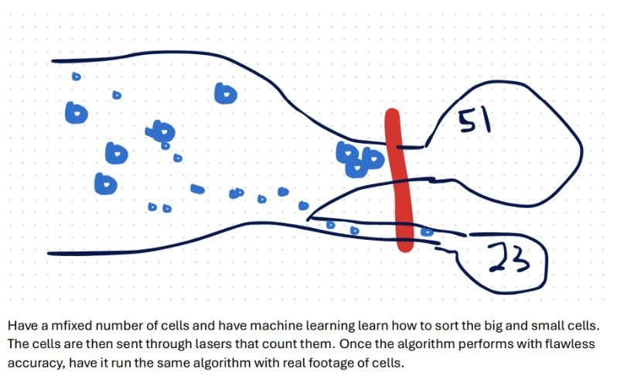
The next idea that was considered involved the use of the four-color theorem to separate all the cells and then categorize them by size and shape. The four-color theorem, which had been learned in Discrete Structures, states that any objects in a plane can be colored with at most four colors such that no two adjacent regions share the same color. While this concept inspired part of the final method, the theorem itself was not fully implemented.
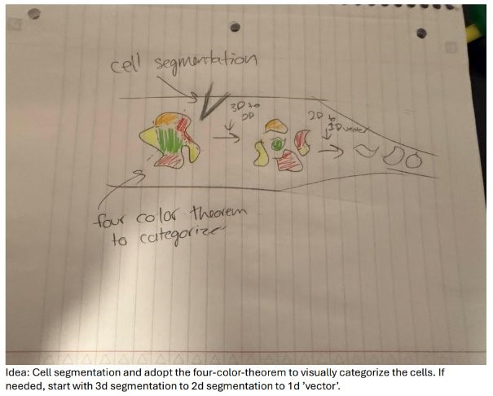
The last method that was proposed involved expanding upon existing MATLAB code—either open-source or inherited from the previous Cell Imaging team. Although considered simple at first, this method was ultimately used in the final project decision.
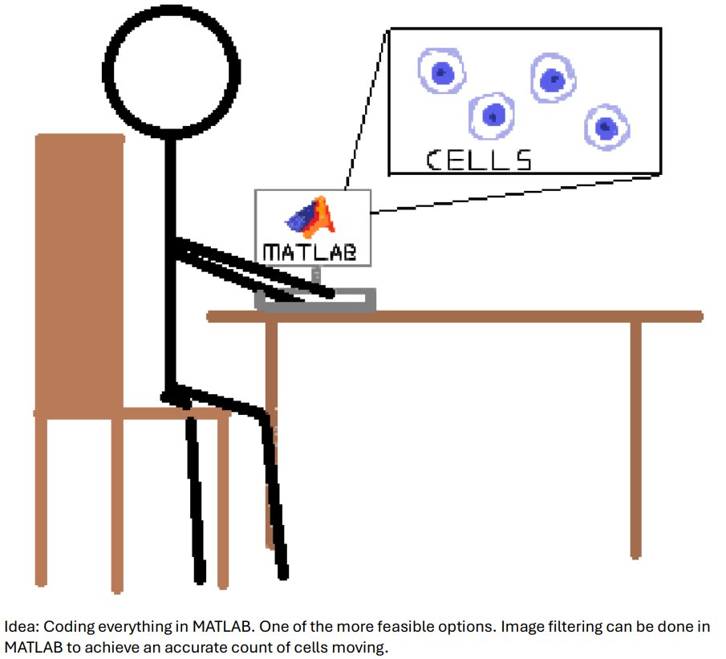

Chapter 2: Design
In this chapter, the constraints, criteria, standards, and final solution for the cell imaging project will be outlined. The limitations that were considered during the design process will be described, along with the specific requirements that guided the system’s development. Constraints such as compatibility with graduate-level users, budget limitations, and the need for accurate shape and size detection will be explained. Criteria regarding the use of MATLAB, reliance on preexisting datasets, and the lack of need for physical hardware components will also be addressed. A decision matrix that was used to evaluate potential solutions will be presented, and rationale behind the final approach will be discussed.

Constraints and Criteria and Specifications
Constraint 1: Be user friendly to graduate and above researchers.
Constraint 2: Be as affordable as possible.
Constraint 3: Detect shapes and cells ss accurately as possible.
Criteria 1: Must be implemented using MATLAB.
Criteria 2: Must use an already existing dataset (aka, we are not imaging the cells ourselves).
Criteria 3: No physical device
Standard 1: ISO 21247-2005 (Otsu’s Thresholding) for statistical methods for assessing process capability and performance in quality management. Not exactly Otsu’s thresholding, but the principles of statistical decision-making and binarization techniques used in image processing align with broader quality assessment methodologies.

Decision Matrix
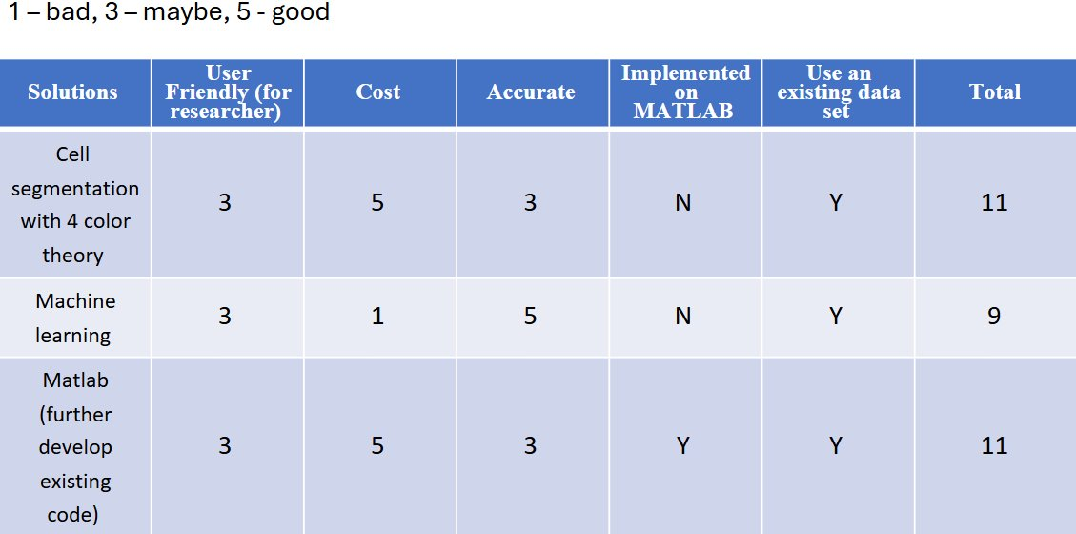

Decision
The winning solution was to use the existing MATLAB from the previous cell imaging team. Instead of focusing on velocity and count, the project will focus on size and shape. This was decided as the winning solution due to being very accessible, affordable, and since it is existing code, the accuracy would be much higher than if the code was created from scratch.

Solution Description
Images are processed through MATLAB in four distinct stages. In the first stage, the images are downloaded into MATLAB. In the second stage, all edges in the image are detected, although at this point it is not yet known whether each highlighted region represents a cell or the surrounding environment. In the third stage, cells are isolated from the background by applying a filter based on roundness, allowing borders to be removed and individual cells to be identified. In the final stage, the identified cells are recolored and overlayed onto the original image for visualization.
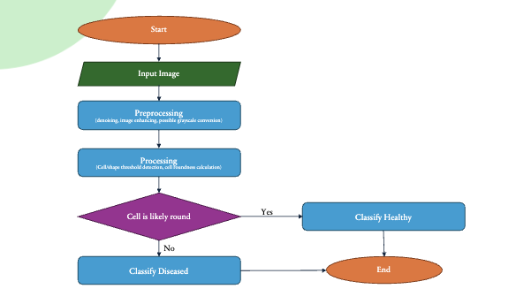

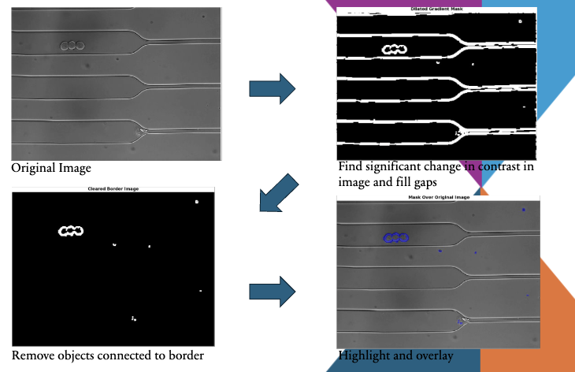

After this MATLAB processing is accurate and very replicable, the images will then be downloaded onto ImageJ. The project is not at this phase due to not completing the MATLAB section. However, there is a clear path that the group is planning to follow when it comes to the usage of ImageJ. Here are some examples of ImageJ’s user’s interface.

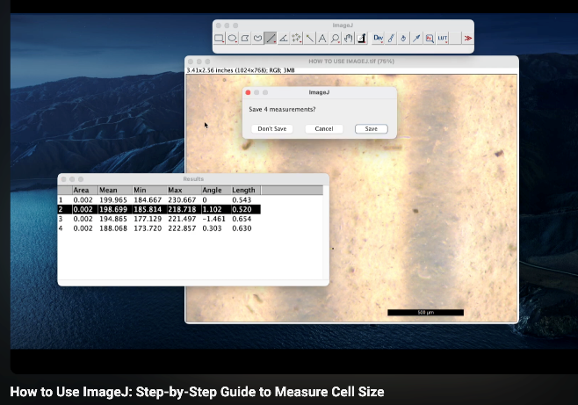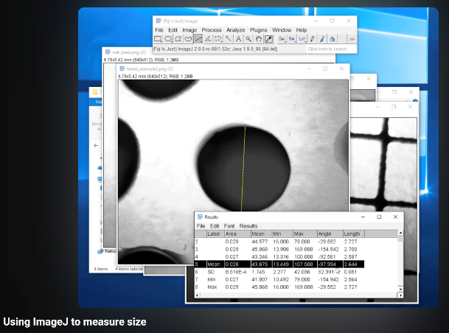

Chapter 3: Project Management
In this chapter, the personnel, project schedule, tools, and material requirements for the cell imaging project will be described. The roles, responsibilities, and expertise of each team member will be highlighted. The structure and responsibilities related to project management, research direction, and MATLAB coding support will be addressed through the overview of team contributions. A breakdown of the project timeline will be presented through the Gantt chart, where the four major phases (research, coding implementation, testing and reiteration, and final release) will be detailed. Key tools like MATLAB and ImageJ will be introduced and/or rediscussed. Lastly, an oveiew of budget expectations will be included, reflecting the project's emphasis on affordability and accessibility.

Personnel
John Ahn
Experience with 3D design and printing is brought to the team by John. Oversight of the Gantt chart has been assigned to him. If a physical prototype is pursued, its design will be led by him due to his strong interest in fabrication. Although only limited experience in MATLAB is held by John, support with MATLAB tasks will be provided by him under the guidance of Jonathan.
Demetrius Schank
A strong work ethic and detail-oriented mindset are brought by Demetrius, making him a strong fit for the role of lead researcher. He has been tasked with narrowing the team's focus by guiding the selection of datasets and identifying the most relevant cell characteristics to investigate. While all research is not required to be performed by him alone, the team’s research direction is expected to be anchored by his input. Responsibility for managing DocuSign for the remainder of the semester has also been assigned to Demetrius.
Jonathan Kim
Proficiency in MATLAB coding is brought to the project by Jonathan. He has been designated to lead the team in developing and implementing code, while also helping others improve their coding contributions. Should a physical component be added to the project, Jonathan will assist with wiring and electronic integration, drawing from his technical experience in those areas.
All Team Members
Completion of the team packet and additional background research will be shared collectively. Assignment submission duties will be determined collaboratively as deadlines approach, due to timing constraints and signature requirements. No fixed submitter has been designated at this time.

Gantt Chart
This is a very rough draft of the Gantt chart that will be followed during the entirety of this project.
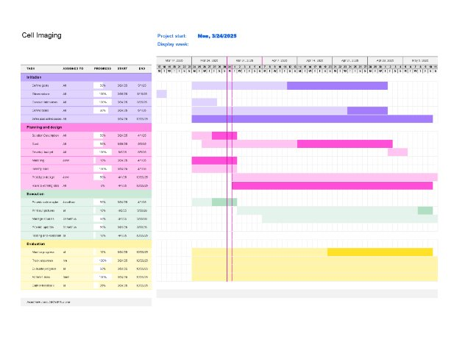
The project will be split into four parts from start to finish. The stages are research, coding implementation, testing and reiteration, and once the product is at an acceptable accuracy rate it will be released.

Materials
This project is primarily software-based. Nothing physical will be built. Data will be collected from public domain research databases. Because of this, no physical materials are expected to be used for the design of the project, but this may be subject to change.

Tools
- MATLAB:

MATLAB compatibility has been defined as a required criterion for the project, as requested by Dr. Wynne. It will be used to enable additions to the existing work that was performed by the previous capstone design group. Therefore, MATLAB is considered an essential tool that will be needed by the group. As students of Villanova Engineering, access to MATLAB is provided as part of the tuition.

- ImageJ:

ImageJ is known as an existing image processing software and is often used for cell image analysis. ImageJ will allow the group’s design to be compared against an already existing system, with the goal of improving upon ImageJ’s performance. It is a program that was written in Java by the NIH and is, therefore, in the public domain (free to use). This software will be used to take the image processed through MATLAB and will measure the size of the cells.

Budget

Item | Manufacturer | Cost per unit | Num. Units | Total Cost
MATLAB | MathWorks Inc. and Simulink | $0 | 3 | 0
ImageJ | National Institutes of Health (NIH) and the Laboratory for Optical and Computational Instrumentation (LOCI) | $0 | 3 | 0
Final Total |  |  |  | $0.00

References
[1] A. Kummrow et al., “Microfluidic structures for flow cytometric analysis of hydrodynamically focused blood cells fabricated by ultraprecision micromachining,” Lab Chip, vol. 9, no. 7, pp. 972–981, 2009, doi: 10.1039/b808336c.
[2] H. Nishiumi et al., “Utility of Three Flow Imaging Microscopy Instruments for Image Analysis in Evaluating four Types of Subvisible Particle in Biopharmaceuticals,” J Pharm Sci, vol. 111, no. 11, 2022, doi: 10.1016/j.xphs.2022.08.006.
[3] Selvan, R., Bhattacharya, S. Human red blood cell membrane stiffness: why should we study it and how?. Eur. Phys. J. Spec. Top. 233, 3073–3087 (2024). https://doi.org/10.1140/ epjs/s11734-024-01110-9
[4] B. Li, Y. Zhang, C. Zhang, X. Piao, Y. Hu, and B. Yin, “Multi-scale hypergraph-based feature alignment network for cell localization,” Pattern Recognition, vol. 149, p. 110260, Jan. 2024, doi: https://doi.org/10.1016/j.patcog.2024.110260.‌
[5] S. Pallikkuth et al., “A MATLAB-based Instrument Control Package for Fluorescence Imaging,” Biophys J, vol. 114, no. 3, p. 532a, Feb. 2018, doi: 10.1016/j.bpj.2017.11.2912.
[6] E. D’Este, Gražvydas Lukinavičius, R. Lincoln, F. Opazo, and E. F. Fornasiero, “Advancing cell biology with nanoscale fluorescence imaging: essential practical considerations,” Trends in Cell Biology, Jan. 2024, doi: https://doi.org/10.1016/j.tcb.2023.12.001.
[7] E. Hodneland, T. Kögel, D. M. Frei, H. H. Gerdes, and A. Lundervold, “CellSegm - a MATLAB toolbox for high-throughput 3D cell segmentation,” Source Code Biol Med, vol. 8, Aug. 2013, doi: 10.1186/1751-0473-8-16.
[8] H. Shroff, I. Testa, Florian Jug, and S. Manley, “Live-cell imaging powered by computation,” Nature Reviews Molecular Cell Biology, vol. 25, no. 6, pp. 443–463, Feb. 2024, doi: https:// doi.org/10.1038/s41580-024-00702-6.
[9] Z. Wang et al., “Rapid, artifact-reduced, image reconstruction for super-resolution structured illumination microscopy,” The Innovation, vol. 4, no. 3, pp. 100425–100425, Apr. 2023, doi: https://doi.org/10.1016/j.xinn.2023.100425.
[10] W.-D. Jang et al., “Learning Vector Quantized Shape Code for Amodal Blastomere Instance Segmentation,” 2022 IEEE 19th International Symposium on Biomedical Imaging (ISBI), pp. 1–5, Apr. 2023, doi: https://doi.org/10.1109/isbi53787.2023.10230774.
[11] P. Ma et al., “A state-of-the-art survey of object detection techniques in microorganism image analysis: from classical methods to deep learning approaches,” Artificial Intelligence Review, Jun. 2022, doi: https://doi.org/10.1007/s10462-022-10209-1.
[12] Syed Khasim, H. Ghosh, Irfan Sadiq Rahat, K. Shaik, and Manava Yesubabu, “Deciphering Microorganisms through Intelligent Image Recognition: Machine Learning and Deep Learning Approaches, Challenges, and Advancements,” EAI Endorsed Transactions on Internet of Things, vol. 10, Nov. 2023, doi: https://doi.org/10.4108/eetiot.4484.
[13] E. C. Jensen, “Overview of Live-Cell Imaging: Requirements and Methods Used,” Anatomical Record, vol. 296, no. 1, pp. 1–8, 2013, doi: 10.1002/ar.22554
[14] “Basic cell counting and segmentation in Matlab,” Pedro.si, Apr. 24, 2014. https://blog.pedro.si/2014/04/basiccell-segmentation-in-matlab.html
[15]Dan Puperi, “Using ImageJ to measure size,” YouTube, Feb. 06, 2019. https://www.youtube.com/watch?v=xXE7MBiWJIc (accessed May 02, 2025).
[16]Biotosis, “How to Use ImageJ: Step-by-Step Guide to Measure Cell Size,” YouTube, Jan. 17, 2025. https://www.youtube.com/watch?v=Kx7YiB9zltc (accessed May 02, 2025).
‌

‌

Appendix A: Ethnographic Research

Literature Review

Search terms
Demetrius
Search word 1 | Search word 2 | Search word 3 | Search word 4 | Search word 5 | Search word 6 | Search word 7 | # of returns
Cell | image | particle | flow | microstructure | optical | fibers | 21,700
particle | flow | imaging | standard |  |  |  | 3,000,000
MATLAB | cell | imaging |  |  |  |  | 472,000
MATLAB | cell | imaging |  |  |  |  | 472,000
cell | imaging | standard | protocol |  |  |  | 18,000

Jonathan
Search word 1 | Search word 2 | Search word 3 | Search word 4 | # of returns
Microscopic | Cell | Imaging |  | 17,500
Microscopic | Cell | Counting | Image | 15,800
Cell | Imaging | Techniques | Code | 17,300
Microscopic | 2D | Cell | Imaging | 16,300

John A
Search word 1 | Search word 2 | Search word 3 | Search word 4 | # of returns
cell | imaging | through | Capillaries (since 2024) | 17, 500
cell | imaging | issues | (since 2024) | 18, 100
Cell | Imaging | issues | (since 2024) | 18, 100
cell | imaging | Artificial | Intelligence (2024) | 17,600

References

Reference 1: Microfluidic structures for flow cytometric analysis of hydrodynamically focused blood cells fabricated by ultraprecision micromachining
Student Name: Demetrius Schank
Author(s): A. Kummrow, J. Theisen, M. Frankowski, A. Tuchscheerer, H. Yildirim, K. Brattke, M. Schmidt, and J. Neukammera
Journal/Publisher: Lab on a Chip (journal)
Year: 2009 (published)
Summary: In roughly a paragraph, summarize what this article was about and what you learned.
The article discusses the development of microfluidic structures for flow cytometric analysis of blood cells fabricated through ultraprecision micromachining. The authors studied blood cells primarily with ultraprecision milling to highlight the advantages of microfluidic-based flow cytometry: the advantages include but are not limited to precise cell alignment, reduced sample volume requirements, and enhanced detection sensitivity. The authors detail the fabrication process, enabling the creation of highly accurate microchannels that guide blood cells into a single-file flow for analysis. Experimental results demonstrate the effectiveness of these structures in maintaining stable flow conditions, improving measurement accuracy, and potentially offering a cost-effective alternative to (at the time, ‘current’) conventional flow cytometry techniques. The findings suggest that this approach could advance biomedical diagnostics by enabling portable and efficient blood cell analysis.
Key Takeaway:
- Coefficient of variation (CV) is used to quantify flow cytometry
- Switch from Lithography to ultraprecision, Three-dimensional designs drawbacks and benefits
- Microfluidic-Based Flow Cytometry is effective for analyzing blood cells compactly and efficiently.
- Hydrodynamic focusing is a technique of glow cytometry using fluid confined into a narrow single-file stream for precise cell analysis.
- Authors utilized ultraprecision micromachining to develop highly accurate microchannels for stable flow conditions
- Less blood is needed for the analysis the authors described compared to traditional flow cytometry
- Suggested technology may develop into portable conventional systems (hence why it is in the lab-on-chip journal).
CRAAP:
Currency: The article is not current enough to discuss any ‘ground-breaking’ technologies. Their ‘new’ method of cytometry may already well be standardized now. More context on what the industry ‘norms’ is currently required to be fully sure. The article may be too new to be a ‘seminal’ work, but depending on the current technology, it may have relevant background information.
Relevancy: The article is highly relevant, as the authors were developing a new way to achieve cheaper and more efficient cell imaging analysis. It discusses their development in procedure in much detail, opening gateways to research.
Authority: Head author, Dr. Andreas Kummrow, has been a member of the international society for optics and photonics since 1995. He has been affiliated with German National Metrology Institute at some point in his career and has attended numerous conference proceedings and is credited as an author or collaborator on many journal publications. Finding more personalized information is harder since he was active in the late 2000s and early 2010s, but he certainly has experience with journal publications to say the least. Furthermore, the journal “Lab-on-chip" is a well-known journal that publishes findings on technology at the nano scale.
Accuracy: This article was published in a peer reviewed journal in 2009. The head author has been involved with many published journal articles reviewed during conference proceedings. As previously mentioned, the journal is also well known. The information is likely accurate.
Purpose of the resource: The purpose of this text is educational, as the authors are sharing their findings. There is no obvious promotion or bias seen in the article.
In-text citation: [1]

Reference 2: Utility of Three Flow Imaging Microscopy Instruments for Image Analysis in Evaluating four Types of Subvisible Particle in Biopharmaceuticals
Student Name: Demetrius Schank
Author(s): Haruka Nishiumi, Natalie Deiringer, Nils Krause, Saki Yoneda, Tetsuo Torisu, Tim Menzen, Wolfgang Friess, Susumu Uchiyama
Journal/Publisher: ScienceDirect
Year: 2022
Summary: In a paragraph, summarize what this article was about and what you learned.
The article investigates the effectiveness of three flow imaging microscopy (FIM) instruments—FlowCam, Micro-Flow Imaging (MFI), and iSpect—in analyzing subvisible particles (SVPs) commonly found in biopharmaceutical formulations. SVPs are critical quality attributes in parenteral and ophthalmic products, and their characterization is essential for ensuring product safety and efficacy. The example repeatedly used in the article is the desired prevention of SVPs in therapeutic proteins, which are used in treating various diseases. SVPs forming from such proteins aggregating increases risk of patient immuno-response. The study utilized both morphological feature analysis and a deep-learning approach, specifically convolutional neural network (CNN) analysis, to assess the instruments' performance in classifying these particles.
Key Takeaway: List several key points from this resource that will be important to your work
- Flow imaging microscopy (FIM) is useful for classifying SVPs because FIM provides particle images
- SVPs (subvisible particles) as described in this article are protein aggregates between 2 to 100 micrometers in diameter
- Protein aggregation in therapeutic proteins increase risk of immune system response
- Light obscuration (LO) was used as a preliminary method before FIM, but FIM has better imaging and less drawbacks. FIM supported findings with LO
- FIM can be used to morphological features of particles.
- Another tool used is convolution neural networks (CNN) to classify the images
  - Converts greyscale image to numerical matrix to eventually one-dimensional vector
  - Used pooling and convolution
- Different companies with FIM instruments: FlowCam, Micro-Flow Imaging, iSpect
  - All three instruments worked effectively
CRAAP:
Currency: the article is very up to date, as it was published in November of 2022.
Relevancy: the article is not the most relevant to the project, although it does provide some foundational information about different imaging technologies. The article discusses the characteristics of aggregated proteins that have formed SVPs and the various instruments they used to observe them. This article may serve as a foundation to explore other image analysis techniques and technologies.
Authority: The head author, Haruka Nishiumi, has her philosophy doctorate and bioengineering PhD from Osaka University, which is among the top 3 universities in Japan. During her time at the university, she specialized in Image Analysis and Biopharmaceuticals. Currently, she is researching for Japan Society of the Promotion of Science (JSPS)
Accuracy: The information in the article is peer reviewed and published in a peer reviewed journal. The information is highly accurate
Purpose of the resource: The article has a declaration of competing interests' section in which they indicate no financial or interpersonal interests that could have affected the content. The article is not trying to sell one FIM instrument over another but rather discusses the different results or complications they encountered from each instrument.
In-text citation: [2]

Reference 3: Human red blood cell membrane stiffness: why should we study it and how?
Student Name: John Ahn
Author(s): Rekha Selvan and Sarbari Bhattacharya
Journal/Publisher: The European Physical Journal Special Topics
Year: 2024
Summary: In a paragraph, summarize what this article was about and what you learned.

Key Takeaway: List several key points from this resource that will be important to your work
- Changes in red blood cells (RBCs) membrane stiffness affects ability to deform
- This paper gives 6 methods to study the properties of RBCs
  - Vital for visualizing and quantifying mechanical properties of cell membranes
- Impact of stiffness on microcirculation (flow of blood through vessels such as capillaries)
  - Vital for when imaging cell behavior
- Increase of cell membrane stiffness of RBCs can be caused by medical conditions such as hyperglycemia and sickle cell disease
  - Noticing amounts of stiff RBCs could catch these diseases early before it takes over due to no treatment
CRAAP: Identify the Currency, Relevancy, Authority, Accuracy, and Purpose of the resource.
Currency – This paper was published in 2024, which is current
Relevancy – This paper shows the importance of cell imaging – imaging mechanical properties of cells
Authority – Selvan and Bhattacharya are experts in biophysics and cell mechanics
Accuracy – This paper is very accurate in what stiffness in RBCs could mean, as well as the current methods used to research cell mechanical properties
Purpose – familiarize readers with various experimental techniques to gauge mechanical properties of RBCs and why it is important

In-text citation: [3]

Reference 4: Multi-scale hypergraph-based feature alignment network for cell localization
Student Name: John Ahn
Author(s): Bo Li, Yong Zhang (and more)
Journal/Publisher: Science Direct: Elsevier
Year: 2024
Summary: The main objective of this paper was to address the significant variations in cell shape, size, and colors. All of these are seen as feature misalignment issues between cell images and location maps. The paper introduces a feature alignment model that gets rid of these issues. In this paper, I learned the basic issues with current cell imaging and how to solve them. There are better ways to solve such problems, but that is our job.

Key Takeaway: List several key points from this resource that will be important to your work
- Primary objective of cell localization is determining position of cell precisely
  - Used in, but not limited to, embryo counting and cancer cell detection
- Challenges – variability in size, shape, and color
  - Uniformly – challenge of feature misalignment between cell images and GT (ground truth)
- Convolution Neural Network (CNN) - significantly improves cell localization performance by learning from input images
  - Detects complex shapes and patterns in cell structures
  - To address color variance, used a multi-scale difference convulsion module that mitigated pixel differences between cells of varying color depths
  - Existing CNN-based still have misalignment problems due to convolutional kernel design
- Two drawbacks: 1) use of convulsion kernel for uniform mapping of local regions
  - 2) design of local receptive fields limits the feature aggregation capability
- Section 2 – related works and section 3 – proposed methods in practice
  - Used in medical image segmentation
- “Deformable convulsion layers” - also utilized in DefED-Net for liver tumor segmentation
CRAAP: Identify the Currency, Relevancy, Authority, Accuracy, and Purpose of the resource.
Currency – it is very current with it being published in May 2024.
Relevancy – It is relevant to our topic – it addresses common issues with cell imaging
Authority – Bo Li is a postgrad and research computer vision and multimedia. Zhang Yong has a PHD in compsci and is currently an associate professor. His research is in intelligent transportation systems, big data analysis and visualization, and computer graphics.
Accuracy – Yes, this paper is very accurate in what it claims to achieve. There are many experiments and papers
Purpose – Share findings and breakthroughs in cell imaging

In-text citation: [4]‌

Reference 5: A MATLAB-based Instrument Control Package for Fluorescence Imaging
Student Name: Demetrius Schank
Author(s): Sandeep Pallikkuth, Marjolein Meddens, Mohamad Fazel, Hanieh Farsibaf,
Farzin Farzam, Michael Wester, Keith Lidke.
Journal/Publisher: Biophysical Journal
Year: 2018
Summary:
The article introduces MATLAB Instrument Control (MIC), which is a freely available software package tool designed to automate and facilitate fluorescent microscopy systems. MIC uses object-oriented programming to ensure a standardized interface for necessary components, like lasers, cameras, and shutters. The package supports scripting, function creation, and GUI-based control. Also, it enables real-time data collection and analysis within MATLAB users to better fine tune the package to its needs. The software is available on GitHub for use and development.
Key Takeaway: List several key points from this resource that will be important to your work
CRAAP:
Currency: Article was published in 2018, which might be a little too old to be 'current’. Regardless, MATLAB will be a very important tool used for this project, as previous research shared to the group indicates that MATLAB was used to render the imaged photos.
Relevancy: This article is relevant to the project and issue at hand. Again, MATLAB will be used a lot in this project for the actual rendering of images, expanding the toolset that could be used is important contextual information we may need.
Authority: The head author, Sandeep Pallikkuth, currently works as a managing scientist at NIH in the Cellular and Molecular Biology Laboratory. During his doctorate studies at the Indian Institute of Technology, Pallikkuth specialized in microscopy and MATLAB.
Accuracy: The journal that the article was published in IS a peer-reviewed scientific journal. Furthermore, this was a part of Pallikkuth’s graduate project, implying that no false information should be intentionally present. The journal is likely accurate.
Purpose of the resource: To share an accessible MATLAB resource for cell imaging.
In-text citation: [5]

Reference 6: Advancing cell biology with nanoscale fluorescence imaging: essential practical considerations
Student Name: John Ahn
Author(s): Elisa D’Este
Journal/Publisher: Trends in Cell Biology
Year: 2024
Summary: This paper talks about far-field fluorescence nanoscopic (FN) technologies advancements, a revolution in cell biology visualization. Although this breakthrough is valuable, it still requires proper preparation for successful imaging. The paper gives guidance on overcoming challenges and steps on how to optimize FN technologies for cell biology research.

Key Takeaway:
- Limitations of the implementation of FN applications
  - Phototoxicity – absorbed light generates free radicals and reactive oxygen species, causing genomic damage, mitochondrial stress, and protein degradation
  - Low image acquisition frequency – reducing field of view results in decreased contextual info and SNR (signal to noise ratio)
  - Availability and impact of labeling on living cells – drugs can interfere with physiology of targeted molecules
  - Imaging depth and large field of view – important because most samples are not single cell monolayers
    - Requires settings that cause less perturbation of biological conditions
- Although nanometer-scale imaging is good, it is not always preferred
  - Not all biological problems require it
- Challenges in FN
  - The goal is live FN imaging, but high phototoxicity makes it difficult to achieve
  - FN approaches require the use of affinity-based labels to reveal molecular identities and position
  - Labeling density, imaging tool stoichiometry, and linkage error
CRAAP: Identify the Currency, Relevancy, Authority, Accuracy, and Purpose of the resource.
Currency: It was published in January 2024, making it very current
Relevancy: This paper is truly relevant to cell biology research, especially those in cell imaging. It goes very in depth about FN and experiments with data to support their claims
Authority: The authors are experts in microscopy and cell biology and affiliated with reputable institutions
Accuracy: This paper is very accurate in its claims and based on current research. It is also peer reviewed by all the authors, so it is safe to say it is very reputable and reliable
Purpose: The purpose of this paper is to be a resource for future cell imaging research, especially to those interested in using FN technologies.
In-text citation: [6]

Reference 7: CellSegm - a MATLAB toolbox for high-throughput 3D cell segmentation
Student Name: Demetrius Schank
Author(s): Erlend Hodneland, Tanja Kögel, Dominik Michael Frei, Hans-Hermann Gerdes, and Arvid Lundervold
Journal/Publisher: Source Code for Biology and Medicine
Year: 2013
Summary: In a paragraph, summarize what this article was about and what you learned.
The article presented CellSegm, another MATLAB-based toolbox designed for high-throughput 3d cell segmentation using fluorescence microscopy. The software allows for both semi-automated segmentation and fully automated segmentation, which directly improves experiment reproducibility and efficiency compared to other cell segmentation methods (i.e., manual delineation, which is like the manual way of tracing cell boundaries). CellSegm follows a multi-step approach, that includes smoothing, ridge enhancement, watershed segmentation, and feature based classification of cells. It is also command-line based, allowing for scripting and customization for users. The article includes various comparisons with manual segmentation and the software’s performance to demonstrate its applicability.
Key Takeaway:
- CellSegm is designed to efficiently segment fluorescence microscopy images. This improves reproducibility and reduces the manual workload of imaging cells.
- CellSegm is optimized for large-scale image screening, making it more suited for biomedical research.
- Uses a multi-step algorithm including: smoothing, hessian-based ridge enhancement, marker-controlled watershed segmentation, feature based classification of cells!
- Works best with surfaced stained cells
- CellSegm uses MATLAB, thus there are some customizability features.
- Outperforms CellProfiler as of 2013
- CellSegm is freely available and open source.
- Was used to segment human biopsy tissue
- 2d vs 3d cell segmentation
  - 2d analysis single microscopy plane at a time
  - 3d reconstructs cell structures from stacked image slices.
CRAAP:
Currency: Article is too old to be considered current, as it was published 11-12 years ago. May have beneficial information regarding possible imaging tools we can use.
Relevancy: Besides CellSegm’s ability to classify cells based on their features (which is EXACTLY what we want to do), CellSegm is meant for cell segmentation, which is identifying THEN separating individual cells from each other in microscopy images. Although this might help us classify even further, I'm unsure if cell segmentation is exactly what we need to do in this project.
Authority: Head author Erlend Hodneland is still publishing articles as late as January 2025 in a variety of biomedical topics. His articles are decently cited, his top 4 cited articles being used over 150 times (this article being cited 130 times). He is a CMR scientist who specializes in Image processing, numerical modelling, pattern recognition, and machine learning. He earned his PhD in mathematics at the University of Bergen. His experience alone is greatly beneficial.
Accuracy: I conclude that this article is likely accurate for the time it was published (2013). The scientific information is likely accurate, but seeing as CellSegm claims to perform better than former tool CellProfiler, I’m not sure how that holds up today. Regardless, article was published in a peer-reviewed journal that ran from 2006 to 2020.
Purpose of the resource: Promote CellSegm, a new tool. There is no financial benefit for the researches, as CellSegm is open source and freely available (at least at the time of this article publication). Likely an unbiased source
In-text citation: [7]

Reference 8: Live-cell imaging power by computation
Student Name: John Ahn
Author(s): Hari Shroff, Ilaria Testa, Florian Jug, and Suliana Manley
Journal/Publisher: Nature Review – Molecular Cell Biology
Year: 2024
Summary: This paper explores how computational techniques can improve live cell fluorescence microscopy. It also addresses key problems/challenges such as signal to noise ratio and spatial temporal resolution. It also talks about how hybrid methods that integrate both computation and microscope hardware can improve on those issues.
Key Takeaway: List several key points from this resource that will be important to your work
- Hybrid methods – combining computational approaches with microscope hardware
  - Optimizes image quality and performance
  - Higher flexibility and accuracy in live cell imaging
- Real time data processing used to adapt an acquisition
  - ANNS (artificial neural networks) can detect rich biological events
    - Can feed data back into microscopy as a cue to change the measurements
- Temporal resolution – time between consecutive images of the same part of the specimen
  - This paper included the definitions of many other important words and phrases/names
- This paper talks about computational approaches (including but not limited to those based on machine learning)
CRAAP: Identify the Currency, Relevancy, Authority, Accuracy, and Purpose of the resource.
Currency: This paper was published in February 2024, which is current.
Relevancy: Yes, this paper provides insights into computational methods and other important aspects when researching with cell imaging.
Authority: The authors, Shroff, and Manely, are experts in microscopy and computational biology. It was also reviewed and published by a reputable journal and shows a high level of authority.
Accuracy: The paper is based on research and results and includes much scientific evidence with proof and data.
Purpose: The purpose of this paper was to inform people and other researchers about cell imaging and fluorescence microscopy.
In-text citation: [8]‌

Reference 9: Rapid, artifact-reduced, image reconstruction for super-resolution structured illumination microscopy
Student Name: Jonathan Kim
Author(s): Zhaojun Wang, Tianyu Zhao, and Ming Lei
Journal/Publisher: The Innovation
Year: 2023
Summary: This article talks about the advantages and disadvantages of cell imaging techniques, while sharing an entirely new technique that takes the advantages of other techniques. Their method, called joint space frequency reconstruction-based artifact reduction algorithm (JSFR-AR) combined with structured illumination microscopy (SIM) deals with the main problems of SIM, which are artifacts appearing in images and inefficient algorithms. With their method, they can cut the time to reproduce an image from 3.418 seconds to 0.0057 seconds while maintaining a near-same level of quality. This technique allows for real-time super resolution imaging while having quality images.

Key Takeaway:
- Mentions a variety of techniques with their pros and cons
  - Widefield, Wiener, HiFi-SIM, JSFR-AR-SIM
- Artifacts can be produced by cell imaging techniques
- Technical articles, deconvolutions, and filters are necessary for producing the image. Formulas are included in the article and in the supplemental information
CRAAP: Identify the Currency, Relevancy, Authority, Accuracy, and Purpose of the resource.
Currency: Article was posted on May 15, 2023. It is up to date.
Relevancy: Article is relevant, mentioning the different imaging techniques used to give high resolution photos. The authors mention time to produce images as a crucial factor in imaging, but it may not be as relevant for us as time may not be a limiting factor.
Authority: The three authors all are in the MOE Key Laboratory for Nonequilibrium Synthesis and Modulation of Condensed Matter, School of Physics, Xi’an Jiaotong University. The authors have hundreds of citations.
Accuracy: The article is accurate in highlighting its methods with a video and providing resources when available.
Purpose: Share a new method for cell imaging, two authors are applying for a patent on their method. Patents are good because they incentivize innovation, not necessarily greed.
In-text citation: [9]
Z. Wang et al., “Rapid, artifact-reduced, image reconstruction for super-resolution structured illumination microscopy,” The Innovation, vol. 4, no. 3, pp. 100425–100425, Apr. 2023, doi: https://doi.org/10.1016/j.xinn.2023.100425.

Reference 10: Learning Vector Quantized Shape Code for Amodal Blastomere Instance Segmentation
Student Name: Jonathan Kim
Author(s): Won-Dong Jang, Donglai Wei, Xingxuan Zhang, Brian Leahy, Helen Yang, James Tompkin, Dalit Ben-Yosef, Daniel Needleman, Hanspeter Pfister
Journal/Publisher: IEEE
Year: 2023
Summary: This article’s main purpose is to improve the IVF success rate of clinics. Clinics visually inspect embryos and use one embryo that has the best chance at forming a viable pregnancy. The success rate of an embryo is dependent on its shape and symmetry of blastomeres in the cell. The researchers’ methods aim to get the blastomeres complete silhouette even with the object partially occluded. With different amounts of occlusion, they train a model to recover complete object shapes. They used 7,054 images for training and 4,617 for testing. The researchers outperformed the model at the time by 1.7%. Their method works for any partially visible objects, cells, cars, or pedestrians.
Key Takeaway:
- Uses an occlusion map for overlapping objects.
- Uses a learning model for their algorithm, can be applied to other objects and not just embryos.
- Technical, formulas included for learning, detecting, and segmentation.
CRAAP:
Currency: Article was posted on September 1, 2023. It is up to date.
Relevancy: Article is somewhat relevant; it is hard to apply but it can be relevant towards our topic. Applying learning models towards cell imaging is a path that could be taken. Overlapping cells could also be relevant to our topic.
Authority: Six of the nine authors are from the School of Engineering and Applied Sciences, Harvard University, one is from Boston College, one is from Brown University, and one is from Tel Aviv University.
Accuracy: The article is accurate in comparing its methods to state-of-the-art methods during its time.
Purpose: Improve the success rate of IVF by easing the selection of which embryo is viable for pregnancy.

In-text citation: [10]
W.-D. Jang et al., “Learning Vector Quantized Shape Code for Amodal Blastomere Instance Segmentation,” 2022 IEEE 19th International Symposium on Biomedical Imaging (ISBI), pp. 1–5, Apr. 2023, doi: https://doi.org/10.1109/isbi53787.2023.10230774.

Reference 11: A state-of-the-art survey of object detection techniques in microorganism image analysis: from classical methods to deep learning approaches
Student Name: Jonathan Kim
Author(s): Pingli Ma, Chen Li, etc.
Journal/Publisher: Artificial Intelligence Review
Year: 2022
Summary: This article covers many methods of computer image analysis in chronological order. The authors go from traditional image processing to traditional machine learning, to deep learning methods. Microorganism detection from 1985 to the present (2022) is discussed here. This article serves as an overview of methods, including accuracy, segmentation, and edge detection. The authors also share how they sifted through papers and methods.
Key Takeaway:
- For classification, accuracy, sensitivity, specificity, and precision are the criteria. May consider using this as the standard
  - TP, FP, TN, FN
- Countless methods, notable ones is: Classification based methods with geometric features
  - Methods from 2003-2015
- Another notable one: Machine Learning methods
  - Methods from 2009 – 2020
- Some work on bacteria and other cellular structures, but all are applicable
CRAAP:
Currency: Article was posted on June 07, 2022. A little outdated in techniques.
Relevancy: Article is truly relevant. Goes through an overview of techniques, highlights examples of how some techniques work, and cites each method with their own paper.
Authority: Authors are from the Microscopic Image and Medical Image Analysis Group, College of Medicine and Biological Information Engineering, Northeastern University China
Accuracy: The article is accurate, citing sources and references to papers and making it easier to visualize.
Purpose: Help researchers obtain a comprehensive understanding of the process, research, and future in microorganism detection

In-text citation: [11]
P. Ma et al., “A state-of-the-art survey of object detection techniques in microorganism image analysis: from classical methods to deep learning approaches,” Artificial Intelligence Review, Jun. 2022, doi: https://doi.org/10.1007/s10462-022-10209-1.

Reference 12: Deciphering Microorganisms through Intelligent Image Recognition: Machine Learning and Deep Learning Approaches, Challenges, and Advancements
Student Name: Jonathan Kim
Author(s): Syed Khasim, Hritwik Ghosh, Irfan Sadiq Rahat, Kareemulla Shaik, Manava Yesubabu
Journal/Publisher: EAI endorsed Transactions on Internet of Things
Year: 2023
Summary: Manual microscopy and culture techniques are outdated for analyzing microorganisms. The paper goes into an in-depth analysis of machine learning and deep learning for recognizing and classifying microorganism images. Using eight diverse types of microorganisms: spherical bacteria, amoeba, hydra, paramecium, rod bacteria, spiral bacteria, euglena, and yeast, they made these data sets. The use four different algorithms to classify these cells, and from them, the convolutional neural networks (CNN) had the best accuracy. They also included a literature review focused on image recognition techniques and microorganisms. Used a total of 795 microscopic images.
Key Takeaway:
- Deep Learning and Machine learning had accuracy of around 90 percent
- These models can be good to use but require a decent amount of data before being able to use them.
- Precision, recall, and accuracy are important to evaluate a model
CRAAP:
Currency: Article was posted on November 27, 2023. It is up to date.
Relevancy: Article is somewhat relevant; This method uses machine learning and deep learning to categorize bacteria. Could apply to our topic.
Authority: Authors are all from the Vellore Institute of Technology University, except Manava Yesubabu who is from the Vardhaman College of Engineering.
Accuracy: The article is somewhat accurate in showcasing machine learning and deep learning. Images of the model identifying the images and classifying them are desired.
Purpose: Explore machine learning and deep learning, especially the CNN model. The purpose is to educate, and foster future improvements to progress these types of learning.

In-text citation: [12]
Syed Khasim, H. Ghosh, Irfan Sadiq Rahat, K. Shaik, and Manava Yesubabu, “Deciphering Microorganisms through Intelligent Image Recognition: Machine Learning and Deep Learning Approaches, Challenges, and Advancements,” EAI Endorsed Transactions on Internet of Things, vol. 10, Nov. 2023, doi: https://doi.org/10.4108/eetiot.4484.

Reference 13: Overview of Live-Cell Imaging: Requirements and Methods Used
Student Name: Demetrius Schank
Author(s): Ellen C. Jensen
Journal/Publisher: Anatomical Record
Year: 2013
Summary: (THIS ARTICLE IS TO SERVE AS ‘ENGINEERING STANDARD’)
The article discusses the principles and techniques of live-cell imaging for biomedical research. It explores key factors affecting cell imaging success rates, including the importance of maintaining cell viability, environment control, and minimizing phototoxicity. Jensen compares microscopy techniques (listed in key takeaways) are compared based on resolution, sensitivity, and imaging speeds. The article also highlights ‘current’ (2013) advancements in fluorescence proteins, quantum dots, and atomic force microscopy, ultimately emphasizing their advantages and limitations in capturing dynamic cellular processes. Overall, the study emphasizes the need to balance image quality with minimal cellular disturbance in cellular imaging techniques to ensure accurate biological observations.
Key Takeaway:
- Microscopy techniques: widefield, confocal, multiphoton, total internal reflection fluorescence (TIRF), and fluorescence resonance energy transfer (FRET)
  - Confocal microscopy improves resolution for time-lapse imaging but causes photobleaching and inefficiently uses light
  - Multiphoton microscopy reduces photobleaching and allows deep-tissue imaging, making it ideal for long-term studies.
  - TIRF microscopy enables high-resolution imaging of cell membrane processes.
  - Fluorescence recovery after photobleaching (FRAP) is useful for studying protein mobility and molecular dynamics in living cells.
  - Fluorescence correlation spectroscopy (FCS) measures molecular dynamics at high temporal resolution: it’s good for studying fast biochemical interactions.
  - Fluorescence resonance energy transfer (FRET) allows real-time observation
  - Fluorescent quantum dots offers increased brightness and resistance to degradation compared to traditional ‘fluorophores?’
    - Toxicity is still a concern here.
  - Coherent anti-Stokes Raman scattering (CARS) microscopy provides label-free, high-resolution chemical imaging
    - useful for studying lipids and live-cell dynamics.
  - Atomic force microscopy (AFM) complements optical imaging by providing high-resolution topographical and mechanical data of live cells.
- Live-cell imaging is essential for studying dynamic biological processes
- Maintaining cell viability during imaging is crucial
- Phototoxicity and photobleaching are major challenges
  - requires optimized light exposure and the use of protective measures such as shuttering and oxygen reduction.
- Imaging chambers must be carefully designed to provide optimal growth conditions while maintaining optical quality.
- Fluorescence microscopy is the most commonly used technique and is usually combined with transmitted light methods for enhanced contrast.
CRAAP:
Currency: Article was written in 2013, so it is not very ‘current’, but it offers good foundational information regarding cellular imaging STANDARDS.
Relevancy: Article is truly relevant as it reports, in detail, advantages and drawbacks of different cellular imaging techniques.
Authority: Corresponding author, Jensen, is likely authorized to speak on the subject, as she has many publications affiliate with the University of Nebraska and with Health New Zealand, all seemingly regarding microbiology.
Accuracy: The information is likely accurate, as the article was published in a peer reviewed journal.
Purpose of the resource: the purpose of the article is to provide an educational and technical overview of live-cell imaging techniques. There is seemingly no commercial interest by the author, as the author references various different unaffiliated sources and discusses BOTH the advantages and disadvantages of all techniques discussed in the article.
In-text citation: [13]

Interviews

Interview #1 – Class of 2025 Cell Imaging Group (Preliminary Interview)

Interviewee Information:
- Name(s): Ariana Rojas, Sean Stepanek, Callie Ritter
- Location: Drosdick Meeting Room
- Time and Date: 2/27/2025, ~4:15pm
- Interview Duration: 28:31

Interviewer(s):
- John Ahn, Jonathan Kim, and Demetrius Schank

Questions and Notes:
Questions:
- Tell us more about your groups discoveries. What were some breakthroughs you had? What do you wish you would’ve known before starting?
- Who did they interview to get further information?
- Was there something you wanted to solve, but either unable to due to imitations on time or current technology/knowledge?
Tell us a little about your group’s discoveries
- Breakthroughs?
  - Changed path DEFA from Pedro and NIc on matlab
  - What type of cells 3t3, polystyrenes cells (circular)
    - Jay, current grad student – the one that Klein mentioned
      - Data set from Jay
      - Confirm with Wynne for what data set is in scope
  - Cell seg and shape detection
  - Focused on videos, outputs
  - Exploring routes was grunt work
  - Clear on what types of cells
  - Still matlab
  - Had matlab exposure through matlab class
  - Casas ellipsee detection may work well
- If you had more time, what would you have looked into more?
  - Online data sets and do machine learning
  - Finding data is a PROBLEM
- Thought process starting out?
- What do you wish you would’ve known before starting?

Distinct roles?
- Shared – the beginning
- Project management, but honestly doesn’t really matter as long as anyone is on board
- Split images and videos (alongside, rather than one after another)
Researching and building on what's already fulfilled, with some looking for new things, and merge
Questions about assignments:
What were you guys able to observe during the observation assignment (if anyone remembers)
- Was technical work required by the end of the year?
- What observations worked best?
  - Open the notes given
    - Look at what past team has done
      - Ask Klein if that is allowed
      - Reach out to J, lab work (videos of him being in lab, people using their product) - user friendliness
- Did you need a prototype by the end of the year?
  - Paper presentation
  - Cell detection
  - Shape detection
  - Velocity (maybe)
  - Circle Hough Transformation
  - User friendly output
Who did they interview to get further information? (already answered towards the beginning of the interview)
- The person who started the project?
- Professors or students?
- Is there anyone you wished you interviewed

Where were your strengths and weaknesses, and how did you use (strengths) and overcome (weaknesses)?
Were you able to implement your discoveries (in a lab), or did it stay mainly on matlab?
Matlab, as requested
Was there something you wanted to solve, but either unable to due to imitations on time or current technology/knowledge?
What workshops would you have wanted to attend when preparing for this project?
- Lecture for Matlab IEEE.
- For machine learning, IEEE introductions would be useful.
Jay's interview: “find the velocity of these cells”
Note: GET J
Other:
- Define Data and Define Focus NOW!
- Arfov DEFA
- Costas (Greek guy in Florio notes)

Transcript:
Recording Link
Now, so, uh, before we start, uh, we need your consent, so if you can please just, uh, say your name and say that you consent to being interviewed for the next 15, 20 minutes. I'm Ari, and I consent to being interviewed and recorded for the next 20 minutes. I'm Sean and I also consent for being recorded. I also consent to recorded. All right, nice. So, uh, tell us a little bit about you guys' discoveries. What like breakthroughs that you guys had that maybe uh Pedro, which is the front runner, I guess of the project, um, what breakthrough did you guys have? I don't know, is it like a breakthrough or was it just a change in like kind of trajectory yeah, we kind of went on a different path because we weren't having much success with the methods that he was using. And what were they? Uh, there was like the circle finder, the, there was like a um I forget the exact acronym, I think DE FA or something. um and I was trying to get that to work, I'm not that good at Matab and it was a million scripts altogether, so I failed miserably. and but it would have been really good output. and then we ended up switching kind of our where we were going, like our trajectory because of like an unexpected like, our advisor had a leave, uh during semester and graduate. and then uh then Dr. Kim was our advisor, so then we were asking her kind of where to go. So it' switched a little. I think I could go over like some changes, so when we were originally given the project, it was um an independent research assignment for somebody named Nicholas for Florio, and he had a couple of scripts and like a folder that we can look through, and it was image processing and there was like a you have you guys like looked through the have the same starting resources.. so there's like the um images where there's like clusters of cells, so we're focusing on cell segmentation. And then there's a little bit of confusion over what kind of specific cells we were looking at, if it was 3T3 or just like or what did the, like that when I did my when I talked to the uh Dr. Wynn, like she had said it was mainly these 33 cells with then later, when when we got the cell from J. So, like, we worked we thought we were gonna work with 3T3 cells, we started working with Poly Styrene, but polystyrene., and those are like completely circular. So, when it was like um, I guess 3T3 or like cells that we weren't really sure of what it was, and it was images, we focused on cell segmentation and shape detection. and then when went on leave and we met with Jay, who's a graduate student, who's like doing the lab work or like research around all of this. um and he gave us videos of polyyrene particles moving through capillaries, so those are very circular shaped. And we went from like, you know, that image processing to video processing and finding the velocity of those particles moving through the capillaries. So, like, not necessarily like breakthroughs, but more so like changing traject trajectory. So, did you guys ever get to work with images or did you guys just ahead go straight to videos because of the direction outputs? Yeah, we got outputs, Calguts some noise reduction., but aside from that, there wasn't anything really crazy, especially because like it was a lot of different resources that we were looking through. So it was like evaluating what each resource does, and then seeing if it's a good route to go down, which I think was like one of our bigger barriers was like, do we spend time learning about what this does, so we can use it, or is it just gonna are we just gonna hit a wall, or is it like useless once we really figure it out? the other thing that was tough is that like, since last semester we didn't we didn't really have a ton of uh images that we knew would be like accurate to what they were using for the research. So it felt like if we were like if we were I guess tailoring the code to be detecting a certain type of cell we did early even know. it was at that point. right, thank you.., so just to be clear, like, is this coded in Matab or was it like different software? Matab?. Amazing. Can't we um some more about Matlab, have you what experience did you guys have going into Matlab? um going into this project and then what particular um process, like, what did you find most useful in learning about Matt Lap for this exact project? Is there like something that you remember you had to like really research or look into more about like Matt Lab if anything, like, maybe some plugins or something? When we first got the project, we were like, oh, maybe Python, because it has a lot of like image processing, like, two boxes that you could use or whatever. But then we were told like Matab Malibon. So, we stayed with that, and like the resources that we got in the folders, like the one that you were working on, like those were some things that we were like researching and looking into, but, like, in terms of what we found that could translate well for Yon, Yeah, I mean, maybe I guess if if you wanna try again on bit, image processing, I know there's like image processing tool boxes that I was trying to look through. stuff like that, with like the so that one's I mean, basically what you would need to do that kind of stuff. but yeah, I guess we both we kind of we tried it with that and get it much better than the code that we wanted. The only image processing experience I had was like, the skittles project. Oh, right, yes, because you did ask about. Did you we had? No, I did not do a skittles project at least, but you all y'all took a mat lab course or no? no, they actually got rid of this. We did we all had taken a course in and like the final project, I think it was like what, three classes? and in all three classes, the final project was the same, everybody was like put into groups and you're giving these images of skittles and you have to like write a out lab code that can like count how many skittles are in an image. I guess signals you do a little bit of image processing, but it's more focused on signal. and they took that out too? I don't have signals lab, right?.. Yeah, yeah, they do they give us the labs in the homeworks sometimes, and it's just we have Matt lab code that we run and then we just answer questions. Yeah. I mean, in an ideal world, the that, uh Costas guy, the Greek website that was shared with us. um like, if you got that ellipse detection, uh algorithms work, I know I saw the outputs on the website and it looks really, really good, but Yeah. I think part of the other issue is that like some of the codes that we had gotten were like old versions and like of Matt Lab and that from them, they meant for our data sets. Yeah, and like not commented at all, so it was just like getting something and looking at it, like, okay. I feel like we're like I'm like, kind of going everywhere, but are y'all doing images or are yall doing videos? Like, what is the project, like advertised to y'all as? Uh, so for us, it was uh tried to identify cell boundaries and images. um, and then, if we get that to succeed, upgrade to videos. And if we get that to succeed, upgrade to um characterizing. Yeah, start characterizing cells or or categorizing, I say, but you we went over a categorization, just because there's obviously different types of cells. and then if applicable try to apply machine learning to that, but that's all, you know, foundation, like a c Yeah, sorry, it's all a compounded, if we can get this done and then next. So yeah, it's a very open ended project, which I'm assuming you guys also felt um.. basically I feel like good advice would be like just do something. like, instead of being like, like, oh, what do we do? just do some just do something. okay. Thank you. but also, I feel like machine learning would be really cool. Yeah, you just need a ton of data, yeah doesn't kind of we barely had enough just to do it without machine learning. Yeah, that was a that was kind of a litimate limiting factor for us, is that when we started, we didn't have too much other like other than what was in the folder and then once when it was on leave and we talked to Jay, the grad student, he had given us two videos, three videos. which we couldn't get more because the lab was being renovated. so y' might be able to get some more, um, either images or videos from Jay.. I would say probably the best if I should be like, as early as possible to, I guess, confirm with a Dr. Wynn, like, what types of images, are, like, within the scope of what she would be looking at and try and find, like, as many resources as possible that fit that description of of either videos or images. Yeah. Okay. Thank you, and then kind of changing ears a little bit, but um, just something more. uh, if you guys had more time, what would you have looked into more? H. I don't know if this is allowed, but I would get a data set online and do machine learning. Yeah, that's that's basically what yeah, I was gonna say, too. Would you agree? Yeah, absolutely. like that would be fun.. I think that's even what we were thinking of when we were getting into it, but again, no data, so I didn't couldn't get into it. If they were allowed to just use the data set, it would be awesome. Yeah. but. Thank you. Um, John, do you wanna take the next, um, we can move on to the about the assignment more specifically, like further down? Yeah. I just wanted to like I' hear with different things, like you guys are all having different roles. Can you guys like tell us a little more about that? Yeah. Yeah. I would say, like, we had certain, like, project role descriptions, but if we're being fully transparent, a lot of our responsibilities were shared throughout. And so once we got when whoa. Once we got it went on leave, we kind of had to switch gears and like, do project management and like figure out, okay, like what like change the scope of the project? So, we were all basically working on the same thing. like it went from I forgot what my role was to be honest. I think my role was like I have researcher in my name. Yeah. Honly we kind of just yeah, when we had to go on our own kind of direction, we kind of just split it up and like you were looking through one of the methods and you were doing another one and then Alex kind of just created his own code and that's trying to look yeah. Alex killed a little bit. Yeah, he really did. Yeah. So, I mean, I guess more in retrospect then, like, was it were you guys all I know you guys defined roles and then ended up doing different things, but are there anything in retrospect that you could like define as a role? Other than like someone is the making code from scratch and researchers, I feel like that's kind of what was being said a little bit. I guess it really just depends on what, like, the trajectory of your project is gonna be, because ours was originally understood as images and then it went to videos. um so if you have when, like tell you like, okay, it's fine if somebody does images and somebody does videos, cause that's basically what we're doing, but one after the other as opposed to two at the same time, you could possibly look into that. um I think another thing that we did was like, some of us would be like researching those possible avenues, like through um the the folder. So, like we would look through the folder and be like okay, this is a method that we could look into. and then Alex was kind of just trying to do it himself, like, make his own kind of avenue, while others were researching what had already been done. So, like, that's one, I guess, like those are two roles that you could look into, like somebody that's researching and building up building off of what's already there and then somebody who's kind of just making something. But we would always, like, check in and see, like, you know, what the findings are, what's gonna work. um, and see if there's any way that you could kind of merge things, which I feel like might be a little bit tough, but, yeah. Yeah, I mean, I feel like the nature of the project just is very you have to kind of you have to merge a lot of things together. It's a lot of there's no like one straight set path compared to like what I've seen with some other projects, so um Which like I like I'm rambling now, sorry, but if like that might be a good point to bring up to win is kind of like the open the very, like open understanding of what's supposed to happen. Like, if you can get one specific end goal, or either like ask one from her or establish one for yourself that you might be interested when you're looking into this, I think we'll provide a lot of structure for you for, you know, what you do and, like, just a clear idea of what, you know, success at the end of the semesters will look like. you know, to find that early structure going. Yeah, we were kind of just given a very broad, you know, oh yeah, just do the map have things and then we're like, So if you if you if you ask and you don't get an answer, make an answer. and and go with that and go back. Thank you, thank you. So, I mean, do you guys think we're all good for that? I should ask about the Simon now. Yeah, just some more questions about the assignments. um, currently, we were trying to find actual places to like do our observations. which kind of has led us to a dead end. There's it's like we either have to pay a lot of money or, you know, uh kind of, you know, travel like to hospital you know, we don't really have those connections. So at the moment we're thinking of like just doing these videos, but is there anything that you guys found like actually uh any observations ever actually useful for you guys early on, even if you didn't have a starting goal to begin with? Like when we were doing the observations assignment or just like throughout throughout, just because less redundant work would be ideal. Yeah, that's valid. Um, yeah, I don't know, cause when we did the the observations assignment, we all just opened up the folder together and took notes, and that was what like she let us do that as our observations assignment. um so I would say either, like, look at what we had done and analyze and see where you wanna go from there, if she allows that as an as an observation or if you guys were trying to get in the lab setting, is that what you were like alluding to? like we we were told that we could possibly reach out to Jay and see if we can observe anything that he was doing in slab. um if not, Dr. Wyn suggested a bunch of like driver scene videos, uh, there's I forget the other resources, but just watching a bunch of videos of people doing cell segmentation, stuff like that. that could work, and then as long as Dr Kient improves all those sources and we' upset at the moment, is what it seems like is probably gonna happen, but again, anything that like, is more interactive than watching a video, I feel like would be a lot more beneficial just for our own needs. Yeah. I mean, I don't know, I'm kind of really going with the dome here, but like, maybe even getting well, no. cause I was gonna say, what assignment were we required? Oh, our our testing and we were gonna get people from the bio department, right? So, or like people that work in labs to to use our like result, maybe that could be something, like, seeing people who work in lab settings, like use what we have so far, and like see how that works, especially for like the user friendliness. then you bring it back the end with testing and be like, how do you like it now? more testing. Yeah, that could be a good one, um, possibly if you're interested. Yeah, I think I think the observing like, J with that, cause we used would be really good, too.. videos from that. I just know we kind of ran into things where they were saying, like, we need, like clearances and stuff to even just, like, be there, yeah, so it might take a little at a time. Yeah, I mean, I guess if there's a way to, like, have them, just like, or him to take a take a video of himself, like in the labing it, I guess so it's at least like someone that you can also talk to, not just like some random video from the Internet.. But like, I don't know. So like Jay being in the lab, maybe a video of Jay being in the lab, getting data, or finding people in the bio department here at Villanova using art, like product could be a good one. Um, when it comes to like not necessarily the technical part, cause I would imagine they're not gonna look to the code, but for like the user friendliness and like that part, you know, being able to see them use it could be usedful they could be like, we don't care about that output, but we want to know this.. Yeah. could be one of those. All right, and so in that case, would you guys be comfortable, like, get not necessarily giving us that, but, like, us having access to what you guys had and then testing that and then and then just kind of what you said earlier comparing that, like a year later, with what go for it.. There's no way yeah, there's no way you can't have it. At least my opinion. not to be controversial, yeah. All right, thank you. And then, um, at the moment, we also know that we need a I forget what the word was, but a prototype at the end of the semester. was that how well developed? Yes, because at the moment, like our worst worst worst case, is like we go into PowerPoint and we use that edge tool to like, maybe get edges of images. but that's like if we wanna design how it should look like in the output, if anything. But um yeah, like what did that look like for you guys? I have it. I think I have our prototype. It's pretty. So but we'll see if I think I do though. This is our prototype. Um, so for the record, she pulled out a pretty in depth detail, like outline, I would say, but it's Yeah, so this is basically, I don't know if any of these look familiar. my artistic skills, but yeah, that's from like the cell segmentation. Oh my gosh. from the cell segmentation codes, so we basically looked through you could flip sorry, you could flip through all the pages if you want, but we look through the folder and we kind of I don't know, we just analyzed what we saw and then took what we had and what we knew from the folder and produced, like outputs or like started with some kind of logic to explain, like, what we planned to do at first, what we wanted our outputs to look like. um, and just like to have an idea for whoever's looking at it to see like what like where we were going with this basically. And so we had this all stapled together. very proud. um we had all this staple together and everybody from the class just kind of looked through this packet, so. Yeah, it's kind of tough because like prototype is very geared towards, like a physical project, so we kind of just went with like, like kind of an outline, like pseudo code, like an idea of what we were thinking, we would end up doing. Yeah. and this whole thing is separated into four sections. I'm really trying to remember what they are. I think it's sal detection. sh shape detection. V velocity. Vlocity, I don't know. I know it's in our't know if we planned that from the first semester. I know it's in the presentation, like I wrote it down in our presentation. So if you go to the like semester three, like the one that we are working on right now. Oh, it's in the. I have little four sections, like written down. Alex on the protote is wrong. This is right. Yeah. So, if you go the prototyp site I have the prototype. prototype. Yeah, so it's cell detection, edge detection, shape analysis and user friendly output. Those are the four um sections that this is separated into where we describe what it would look like or what logic we were gonna build on from what we knew at the time. did. Yeah, and then we did videos and cell velocity. but forgot about the prototype. protot yeah, I didn't we didn't or I didn't realize so there's no key in prototype. no second P. noticed but nobody said purpose? No, no. Thank you. We didn't even knowice. Yeah, I like it was way after this. I just. I drew it and spelled it. Yeah.'s get the whole bubble letters. And then one more one last thing about assignments. um one thing we have to do is a workshop, um, so what workshops would you guys have wanted to attend? if there were any, or like, how would you because obviously we can rejudge to the biology department, um see what workshops you might have. But, again, it's not necessarily like a soldering workshop that we can attend just for this. Yeah. The one that we did was like a lecture on I IE E or Iple E's website.? Yeah. Was it? Yeah, then it was like a Matab image processing, like lecture We just sat around and watched it. I was around the computer. I would say and we took notes. Yeah, I mean if you wanna go in the machine learning direction, which would probably be a good direction to go, there there's probably a ton of, like introductions to that and like things that you could like little courses that there's definitely so many videos online of people doing making data sets and like adjusting how they're framed and, you know, evaluating it and cggle and stuff. Okay. And so main points, I'm getting from this, are just in general, is obviously define like a data set early on and with that data set define what, um direction we're gonna take, especially since it seemed like you guys weren't able to use online data sets. It was more, like you had to use um, locally collected, so, like from Jay, from Dr. Wynn, from, uh I forget his name, Nick, and the young, yeah. Um talk to him he's cool.. He seems cool. uh, works at NASA. I saw. Did you guys do Zoom on, or like come in personally? Uh, I did Zoom with him, yeah. He said, reach out again, whenever. But he's just busy, so. Gotcha. All right, um, is there anything else that you guys had in mind or that came to mind? just out of curiosity, did neolas Flo like steer you in any direction? or like what type of advice take is it? It's been so long, I forget what about, but I definitely wrote it down.. Do you guys remember if I said I brought anything after interviewing him? TH. Yeah, I feel like maybe he did point there were a few I think that was when I started trying that what Arf? Yeah, the Arf of DFA methods. That's when I started trying those, cause he said he bound that link to that like website that the Greek guy cost us or whatever. um and he was like, I never really tried this, but it seemed really promising. So then I kept trying it, but I was failing miserably... in terms of like, steering us into a specific direction, I think that resulted from our conversation with Jay. when Wayne was gone, and he was like, here are two videos, find a way to get sell velocity of these moving particles through these capillaries. And that's when most of the work shifted and like when you see our result, like, that's where that comes from, basically. objective, like, very tangible. Exactly.'s good. And I guess like part of our, like, initial confusion, I think had to do with like, just kind of again, the broadness of it in terms of like it's like there's there is like this cell, like kind of biology aspect, but since we don't actually, like, do any of that our cells, it's like, you kind of like we had wanted to like kind of go into that, like, with that information, but I don't even know if that's necessarily, like, really necessary, like, except for just, like, understanding the what outputs and what information they want. It's more of like the focus is is like the image processing and like detecting because early on, at least for like my research for our like literary review, I was still barely unclear about what the project was about, just because the description we were given and we hadn't had time to meet with Dr. Wyn yet. So I ended up looking a lot into, like Microscopy and like that aspect of it, and that's like not really like, we're not actually capturing the stuff our, that's what we thought the same thing. We thought we were like actually gonna be like working with cameras, you know.. So, I think we were also kind of directed by Dr. Wyn to look into different types of like the nomenclature behind, like the cells, just so that we have a better foundation. Oh, no. Maybe. Maybe you don't. Sorry. No, no, I' still recording. Okay.. Anyway, I but yeah, she told us to basically get her biology foundation down in terms of like um the different types of selves because again, our wording in one of our assignments was too broad for um what she knew. So we kind of directed into that sense. I forget my original point before the call. okay. But yeah, um yeah, I think we're all I'm all good. Thank you guys so much for this interview. We will be in contact a lot. Thank you.

Interview #2 – Jiahaw “Jay” Fu Graduate Student

Interviewee Information:
- Name(s): Jiahaw “Jay” Fu
- Location: Drosdick 007
- Time and Date: 3/11/2025
- Interview Duration: 17:57
Interviewed by Demetrius Schank

Questions and Notes:
Questions:
- Can you tell me a little about your work with Dr. Wynne? What is the main premise of your work and how is it related to cell imaging?
- I spoke with the Cell Imaging 2025 team. They said that you directed them towards studying the “velocity of cells.” Can you tell me more about that?
- One problem the previous team had with their project was the extremely limited data set they had to work with. Do you have any recommendations for this?
- Do you have any additional resources (reading materials, videos, etc.) that may help me further grasp the basics of cell imaging?

- Q1: Can you tell me a little about your work with Dr. Wynne? What is the main premise of your work and how is it related to cell imaging?
  - Optical fibers
    - Hollow channels for particles and cells
    - Microfluidics
    - Why cells aren't moving through them.
    - Originally with cells.
    - Connecting
    - Microfluidic pump pumping liquid through.
      - Tube and optical fiber mismatch size.
    - Masters with simulations -
    - Seniors
      - Hard to distinguish background
      - Edit out background – increase detection rates.
    - Microspheres – not natural living
    - Characteristics
      - Light properties
        - Polarization
        - Light absorption
        - Compare values with known studied values that characterize
          - CO2 concentration example.

- Q2: I spoke with the Cell Imaging 2025 team. They said that you directed them towards studying the “velocity of cells.” Can you tell me more about that?
  - Given photos and short videos.
  - Track cell from one to other using mathematics.
  - Self-captured and Oline. Fluid
  - Mostly fluids and microspheres.
- Q3: One problem the previous team had with their project was the extremely limited data set they had to work with. Do you have any recommendations for this?
  - Alot of datasets of cell capillaries.
  - PETE NAS, Nature, Royal society of chemistry – Lab on a chip.
  - MATLAB codes open source.
  - Red blood cells – mostly researched
  - Counting cells – flow cytometry
    - Particle counting. Detect morphology depending on light scattering. Individually align the cells with the light.
    - No work with.
  - Lab on
- Q4: Do you have any additional resources (reading materials, videos, etc.) that may help me further grasp the basics of cell imaging? (Observations)
  - Lab on a chip.
  - Opti fluidics
  - Great resources
  - Possible observation.
    - Equipment
  - Particles in cells.

Other:

Transcript:
Jay Interview Google Drive Link
I think I was going to ask did you see like I guess what the senior project was doing like on like on the age because I can show you I guess if you they are willing to share the their files with us but we didn't see what they have done like finished at the moment. um so, yeah, if you can just uh repeat your name and then give you your consent again on the court. Okay, my name is J Fu and I give on this recording. Thank you. Um, so, can you tell me a little bit about the work that you've done here with Dr. Wynne? um, like, what's the main premise of the research you've done so far and how is it related to cell imaging in general? So, right now I work with optical fiber sensors and um I'm not sure if you really familiar with optic fibers. I know a little bit about them. I know that they use like light to kind of you like a cricide and you transmit like from one to the other, right? But they have like special kind of optical fibers, like instead of um like these special optical fibers have like hollow channels inside. So like instead of um instead of a solid chord, you have like these hollow channels so you can put stuff like cells or particles or stuff like that through them. and they're using biomedical sensing, and right now they're using like microfluids, unless you if you heard it that. It's like nanotechnology, but specifically for some biomedical applications like um pregnancy tests or law testing, stuff like that. It's like fluid mechanics on a very small scale, basically. So, yeah, so like right now I'm working with her and we're trying to like develop, I guess, like a we're trying to figure out like why we can't really put cells through them because like, he done previous experiments and it always ends up like the cells like kind of gets stuck near the uh openings of the channel because it's it's yeah, so we're just trying to figure that out at the moment, so, um, is that like how it started? or did you sort of like you have you always been working with optical fibers since you've got since you've been working with Dr.win and like you've just but, like, what did you experiment with the originalally? and then, like, how did you get to cells? Yeah, that's what I originally started with like. with working with her, yeah. Okay. um, thank you for that. So, I also, again, I did speak with the previous current seniors. Uh, we spoke with their group, and they said that you directed them towards uh or at least like the topic of like studying the velocity of the cells. Can you tell me a little bit more about that and like what exactly Yeah. So, um the last time I met with him was like a couple like I think two months ago and originally I gave them photos of like, um I gave them photos and I believe maybe movies like short video clips of like little particles going through, like these channels like it's basically like a little like a narrow tube and like you have like a dot and it just goes from one end to the other, so I guess what they end up doing was whether they did was um they were able to like track the cell from one end to the other and I guess calculate its philosophy, um based on I guess pixels. I wasn't really sure exactly how they calcul I don't remember off the top of my head, but they were able to do something similar to that. with that? Um, is that something would these uh videos and images were there something that you captured yourself or is it just stuff that you found available online? It was a little bit actually uh yeah, I think I remember I'm not sure if I gave them because I remember I did have a couple of videos of not uh particles or no, it was mostly fluid, actually, so yeah. And I'm assuming well, at least, um for my myself and my group, I would like to get as much as possible in terms of how we can troubleshoot, so if we can if we can detect uh, maybe like the velocity or, you know, fluid moving through these uh, small or were they also, like optical fiber, uh, hollow optical fib channels that they were captured in or is it something different? Um it was a little bit I like the videos I have is mostly fluids at the moment, um, but like right now we were supposed to be using microspheres, but, um, as you can tell, like the lab is still like in the middle moving, I guess, like against the hall, basically.. And so, um, again, when uh another problem that the senior cohort uh had was the very limited data data. Is there any, um good resources that you know of that we could get data from besides, like, maybe I was seeing doctor one as well, where we could expand our data set was there's a lot of data space online actually, like of these uh movies and videos, like other people have like like, I know like, um, like some journal articles like Pete andAS, like they have articles where, like people upload their videos with their research, but there's like plenty of videos online of like, particles moving in these, like tubes and, like there's even um like, Manlightodes, like people uploaded as well. So, like, if anything, you can always I guess work with that as it started point. and then so what was the resources like there was PNAS national Academy of Sciences and like um pretty good nature has stuff like that uploaded.. Royal Society of Chemistry, Lab on the chip is another journal article. Royal Society of Chemistry chemistry, thank you. And that the journal article is called a journal um pub. journal is called like lab on a chip, and that's like basically microputics. I think I actually read one of their articles when I was doing research. It was like, yeah, I I can look at it later, but um thank you for that.. Um, I know also the uh Cenhort, I think they focused mainly on a mill ionium cell. Um, my group, we were also not necessarily expanding the type of cells, but what types of cells would be easy for us to detect in terms of shapes and cell edges. Do you have again, this is very open ended question is there any do you have any idea where we could possibly start with that? probably blood smells like red blood cells are the most timely studied cells gassing, so. So there's probably a lot of like data for that. cells. Okay, and then I also know that, uh documenting formed us of, like the manual cell counting in terms of like, how they kind of used to do set or still do a cells an mutation. that's kind of why we're doing the project to begin with. um do you have any experience doing that? I kind of wanna know how, in terms of like user friendliness or like in how tedious that process is, how we can. I'd Gotcha. Exp experience with that if anything like I guess like implementation wise like? Yeah. um like any like where to start, I guess. um I guess like what you could start with is like uh I'm not sure if you ever heard a flow psychometry. No. Uh, CYT O M E T R Y It's basically um like it's a process zone. It's actually the process is itself particle counting basically. like you can basically detect the properties of like cells or like hemorheology and stuff like that, based on how the light scatters from the surface of the cell. So, one of the processes in that technique is like, you have to like, individually line the cells through the light as like, so if you have a light source has perpendicular to the direction of travel, so you would have to, like, basically move each particle to individually. Okay, and that was like I guess that would be using, like, maybe infrared or something, like, okay. you know, any or just okay. Thank you. Um, have you ever, like, worked with photos that time you show yourself or again, just. Um, so in terms of just getting, I know you already give us some like resources, uh, but just as someone that like, complete Sider of like, uh, I guess any microbiology in general, is there any like good s good um like foundational topics I should know, just so that I can go like headstrong into this project. Um there's it. I was trying to think of like yeah. I guess the only, like, if he had anything to start with, I guess he can Google lab on a chip, because that's what, um, the general topic is a lot of topics fall under the category or outos fluidics. um alto fluidics and lab on a check would probably be, like the best art points. Google wiser, you know, term wise. And do these also have, like, videos and maybe definitely? Okay, thank you. And then, uh another one of the assignments we have to do is, like observations, and at the moment we're probably just going to um find, like all my documentaries or online resources to, like, watch and then obviously reserve them. But I'm not sure if you I know I'm not sure what the lab situation is here, but is there a possibility that we could come in and observe what you do in the lab um, anytime I guess in the next two weeks? maybe I have to get back to you on that because, like, right now, I'm kind of stuck on this one part like, setting up equipment Ise I'm stuck on this small part. so I was gonna talk to talk to Web actually tomorrow, but, um, if it does go well then, yes, if not, I was gonna say I do have, like being on videos. I'm not sure, like, anything would be helpful. um, just because, again, we kind of asked Dr. Wyn and she said, if we can't observe you, and then just find online resources, and then we have to get them approved by our, um, I guess the first the professor that runs the class, her name is Dr. Klein. I'm not sure if you know of her. um, but yeah, especially because this project is very not traditionally, like big engineering projects like you're not building anything huge or anything. There's it's a the assignments are kind of up for interpretation for us, so we're trying to get as much uh outside the box thinking as possible. and again, we did ask Dr. Wynn about any, like, in person observations. um she mentioned like a summer course that she does, but like, you would have to pay thousands of dollars for that and everything. um so, you know, anything that we can observe in person, um that we can afford, that would be really helpful. I think of something, I guess, like um if anything, I can definitely cause like use this room sometimes to like, um check, like, whether or not, like the particles actually get inside the cell, so, like, if a had, I guess I can show you, like, uh, pictures of that under the micros. If anything., no, that would be really helpful. And then, um so you said you were, like currently having issues like getting the particles to flow through the optical fly. I'm gonna call them Capillaries just because that's what um, Dr. Wyn refers to them as, but like, is there any, like, is it the problem, is it just having them exit the capillary or is it just like getting not able to even fit into them to begin with? you like connecting too up tube like the how to find it because like you have like a pop a what does that mean, connecting the tube to the opposite? If you have like a microfluid pump which is basically like a uh like a small pump that just pumps liquid. drew pressure, and like the tubing that you use from for the uh pull is like a little bit bigger than an optical fiber. So, like, right now, obviously it's kind of hard to, like connect them together because, like, the tube is like, I know, like kind of like about it's like very small, but then, like the optical typapers, like, it's like a strain over here, that's how small it is, so yeah. So you're having trouble kind of fitting them together, like a, like probably the hardest part right now. Okay. and then, um, just curious, uh, on my end, like, uh, so you're here for graduate research. um, I'm not too sure how that works, but in terms of like, did you come here just to kind of study cell imaging with Dr. W or was it like, like a program that you kind of, I was here from my master and afterwards I was um like I just wanted to finish a project, so I decided to stay. Okay, and then what was that master's on the same topic? and then you said you also had, like a not necessarily copy, but you had like this senior cohort. um like or the current seniors their project. Is there any like, not flaws, but anything that you have in their project that you would like to see improved upon on our project. I don't top of my head because I don't know, the last time it was like two months ago and I remember they showed me like I got yeah, they showed me like um how they able to calculate how fast the particle was flowing, so I guess something would be like, I guess tracking each particle or like counting them, but I don't know if they actually did that or not, to be honest. um the uh. I guess one thing actually would probably be the um because like the videos I take on my like the videos I take in the lab is like usually um like the background this is like very like it's hard to distinguish the, like vapulary in from the background because like the background is like I'm not sure where the right where you describe it, they're like something like this is just there's like low contrast between them, kind of, or kind of, I guess like something like to um specifically like, yeah, to edit out like everything out in the background just to see the just to see the capillary and the particle floor right yeah. That could, yeah, I think that could help with the detection rates and stuff, just because it's not gonna be looking in the background. Okay. And then, have you worked with any other than, like, the seniors, any other like cell detection programs? Is it like kind of is it like a new thing or is it just like not um reliable enough to be used in the lab? Or yeah, cause like, I don't know what you do with it. Once you the theoretically get them into the optical fibers, are you gonna be counting them, or like what exactly are you trying to do? Well, right now like the next part I guess thesis would be like I said, we're doing them with micros cures right now and then we're gonna be doing in cells. Okay, Microspheres are, uh, just like nod spheres basically made out of a five day, I guess. So, like, uh, what we wanted to do was basically measure like light properties like b French and stuff like that, Petrosc P. has method to detect cells for like, nanotechnology applications. Okay, yeah, cause she said, um, Dr. Wyn, sorry, was uh, very, at least on the project description was hoping uh characterize them as well. So, like the characteristics would be, um, like the light properties and then what else again. Um light properties like uh polarization. and light absorption, like, basically what kind of frequency the cells or microspheres are absorb that. And then what would that what would these, like values give, like, tell you about the cell? is are they like known values of different types of cells? Okay. like, usually each cell or like type of cells. Well, I know, for example, like, uh, like carbon dioxide, right? Like, if you shine like light at a certain frequency, like, it would absorb like a certain frequencies and, like, you can tell, like it's a uh it's a carbonate atom where it's an oxygen atom at because of those frequent it absorb Okay. and that way you can characterize or at least in that a comp dioxide, you can characterize that as the molecule. mole and stuff like that theoretically, that can be applied to um cells then. say like if it's a carbon outside, like, like optical fibers were used to, like, um monitor a CO2 emissions and stuff like that, just you can cause you because you could some measure like concentration and stuff like that as well. Okay. um yeah, I think that's all. Thank you so much for meeting with me again, Jay. Um, and then we probably likely be in touch with lot in the future the next y are you here next year as well

Interview #3 – Jasmine Soriano, senior pre-dental student

Interviewee Information:
- Name(s): John A
- Location: Zoom
- Time and Date: March 17, 2025, at ~7 pm
- Interview Duration: 15:13

Questions and Notes: (I didn't take notes during the meeting, besides the ones listed)
Questions:
1) Why is understanding cell biology important for your field of dentistry?
2) What is cell counting, and why is it important?
3) Can you list some ‘oral cells’ you are familiar with? What is your familiarity with cell segmentation and imaging?

start w quick introductions
ask for consent to continue recording

if you’ve done bio research with a professor, I can ask about that before going into actual questions
very basic: why is understanding cell biology important for your field of dentistry?

Can you list some oral cells you are familiar with?
I looked online and found some names of oral cells, such as (insert cells here) how do they contribute to tooth development?

ask about background / familiarity w cell segmentation and imaging?
(idk anything about this tbh)
Can you tell first us what cell segmentation is, and why it’s important in the dental field.
How does it help with identifying cells such as ameloblasts and odontoblasts?

cell counting
What is cell counting, and why is it important? in bio, dental, anything you are familiar with
How does cell counting contribute to diagnosing oral diseases, such as oral cancer or periodontal disease?
are we looking for clusters or shortage in cells? structure?

As technology continues to advance, how do you see these advancements in cell biology improve dentistry in the future? or rather are there any improvements to current tech that you wish to see when you’re working as a dentist?

ending
Is there anything you wished we would cover but weren’t able to do yet?

cancer treatment

gene editing
research: micro-RNA regulation
inmate regularity
first line of defense

light microscope -

Transcript:
https://app.tactiq.io/api/2/u/m/r/stgD84V3pitbsFyvzq5h?o=sl

Yes. Hello?
Hi.
Hello, I'm John. Can we just ask you for your consent first before we start this interview?
Yes, I consent.
All right, thank you. All right, can you give us a quick introduction before we start? Like, who are you? Have you done any research? What do you know about cells or cell imaging or counting?
Okay, so my name is Jasmine. I'm a senior at Villanova on a pre-dental track and I'm starting dental school in July of 2025. I did do research in the summer of 2023 at a cancer biology and immunology lab at Columbia University. And I worked under Dr. Momin Haravi in researching genome engineering for cancer treatment. And I observed the doctors utilizing biochemical techniques such as CRISPR and Cas gene editing to modify specific regions of DNA to treat cancer. And then I also researched topics including micro RNA regulation of innate immunity and the role of exosomes in head and neck cancer. So I kind of took part in that lab for about a month, I'd say. And in terms of cell biology, since I'm not fully in the dental field right now, and I'm not learning anything specific to dentistry, the only things I really know are from what I learned about in my past science classes that I've taken here at Villanova.
Sounds like you have a lot of background in cancer treatments and gene editing instead of cell. So this interview can go any direction you wish to go, but is it okay if I ask you some questions about cell segmentation or are you not familiar with that?
Yeah, I could talk about how cell biology would be important in my field of dentistry.
Can you tell us a little more?
Yeah, I think it's important for dentistry because it's important to understand in terms of understanding the tissues and the organs in the mouth, how they function and heal, and how they respond to different treatments. For example, tissue regeneration and healing—dentists need to know how cells in the gums, teeth, and bones regenerate after injury or surgery. This helps in planning for a successful recovery and healing after procedures like extractions, implants, or gum surgeries.
And then maybe understanding diseases in the mouth. Many dental conditions like cavities, gum disease, and oral cancers are related to cellular processes. So a solid understanding of cell biology helps dentists in diagnosing, preventing, and treating these diseases more effectively.
Also, treatment of oral infections—periodontal disease, which is gum disease, is mostly driven by bacterial interactions with the cells in the mouth. Understanding how bacteria interact with immune cells can help dentists figure out better treatments and prevention strategies for their patients.
Thank you. Well, before coming to this interview, I did a little research on dentofilin cells. Are you familiar with ameloblasts or odontoblasts by any chance?
A little bit.
All right. Do you know how they contribute to tooth development or anything around that nature?
So I believe ameloblasts are responsible for the formation of the enamel, which is the hard outer layer of the tooth. They secrete some protein to form the enamel during the final stages of tooth development, and enamel formation is known as amelogenesis.
And odontoblasts are responsible for forming dentin, which is the hard tissue beneath the enamel. They secrete dentin matrix, which mineralizes into dentin, and they play an important role in the earlier stages of tooth development.
So it seems like these cells are kind of important to our oral health, right? Do you know anything about cell segmentation and why it's important with these kinds of cells?
Cell segmentation is the process of identifying individual cells in microscope images. I think that it's important to be able to know the process of cell segmentation in order to identify certain cells in the mouth, such as ameloblasts and odontoblasts. Understanding the techniques in cell segmentation and imaging is important for dentists.
Are you familiar with any techniques by any chance? It's okay if you're not.
I'm not.
No worries. Can you tell us a little about cell counting? What is it, and why is it important? Not just in the dental field, but in the medical field as a whole.
Cell counting is determining the number of cells in a specific area. It helps with identifying the progression of a mouth disease or oral cancer. Depending on the number of cells increasing in the mouth, it could show more progression of the cancer. So cell counting in certain areas of the mouth is important for diagnosing some oral diseases.
Is that correct?
Yes, so in periodontal disease, cell counting helps measure the number of immune cells in the gums, which provides insight to the dentist about the extent of the infection. And in oral cancer, counting cancer cells helps in staging the cancer—how bad it is—and determining treatment options based on how many cells are in the mouth.
That's pretty cool. Well, did we miss anything that you wanted to talk about? It doesn’t have to be related to cells; it can be anything about your research, your past, or your favorite time in science.
I guess I'm just excited to learn more about cell biology. I think it's important to have a good background in it as a dentist. A lot of the time, you think about the clinical aspects—interacting with patients and using instruments—but it's also important to have a solid foundation in the actual cell biology of the mouth and what you're dealing with. Because ultimately, you're treating a patient and trying to develop a better plan for them. So I'm excited to learn more about that in dental school.
Oh wow! Have fun with that! As technology continues to advance, is there anything you want to see once you get into the field of dentistry?
I'm not too familiar with dental technology other than what I saw when I shadowed, like 3D oral scanning. But I'm sure there's a lot of advanced technology that could help with live cell imaging, which would allow dentists to visualize ameloblasts and odontoblasts. I think it's important to stay updated with advancing dental technology because there’s always something new.
Going back to your research topics—microRNA regulation and innate immunity—can you tell us a little more about that? If you're okay with that.
Yes.
Can you start with microRNA regulation? What is that?
The research I did in the cancer biology and immunology lab dealt with microRNA regulation of innate immunity, which is the body's first line of defense against pathogens. MicroRNAs are small non-coding RNA molecules that regulate gene expression by binding to mRNAs—messenger RNAs—and either causing their degradation or inhibiting their translation into proteins. They influence a variety of biological processes, including immune responses, cell differentiation, development, and stress responses.
Interesting. I also heard that you did some cancer treatment research. Was that correct? Or were you just shadowing treatments?
Yeah, my role in that mostly had to do with what I mentioned before—microRNA and innate immune pathways. I researched topics like that. The more hands-on things I did were with CRISPR and gene editing. We worked with small trays and observed different cell samples.
I think I covered most of the topics I wanted to go through. Is there anything else you wish we had covered but didn't?
I think that’s basically it. The question about technology for cell imaging—something just came to me. I feel like light and fluorescence microscopes would be a good answer for that. We used those in biology.
Can you tell us a little more about that?
A light microscope uses visible light and a system of lenses to magnify and view objects too small to see otherwise. It’s commonly used in biology and medicine. I used one in research to look at cell samples.
Was that a light microscope or fluorescence?
Honestly, I'm not even sure. I just know we used light microscopes, and fluorescence microscopes were something we talked about too.
Okay. Well, I don’t have anything else on my sheet. If there’s nothing else, we can end the recording here.
Okay, perfect.
Well, thank you, Jasmine, for this recording. I hope to talk to you soon.
Of course, you too. Thank you.

Interview #4 – Dr. Meltem Izzetoglu, Associate Professor

Interviewee Information:
- Name(s): Jonathan Kim
- Location: Drosdick 327
- Time and Date: 3/19/2025, 2:20 PM
- Interview Duration: 17:42

Questions and Notes:
Questions:
1) How has AI and Machine learning be used in the past for your work or research?
2) What are some factors to consider when planning on working with machine learning?
3) What are some databases to look through? Are there any databases or sources you can think of related to cells, capillaries, or image processing?

Consent to being recorded
Quick introductions – give me a background

Our work – Categorizing / counting cells because it is done by expensive machines or manually done which could be more efficient. Counting cells moving through capillaries in images, then videos, then identifying certain cells. Mammalian mouse cells. Applications in medical field, like pregnancy tests.

Dr. Wynne, our advisor, suggested this interview because of your background in AI / machine learning, how have you used these tools in the past for your work or research?

Our group would like to see if machine learning is a possible path for us, but are worried about the costs in doing it, what are factors to worry about when starting machine learning?

What are some databases to look through, for examples of anything cell capillary related? (advisor mentioned NIH or NLM (national library of medicine))

Other:
Recording Link

Transcript:
OK, so I just need your consent to being recorded just for like a transcript. Great. So I'm Jonathan as you may know and can you give us a little background about yourself? I work on biomedical engineering field, primarily focused on brain imaging and for injury, detection, and monitoring and also for cognitive activity assessment. Using wearable noninvasive methodologies specifically using optic space method called F news functional. Other Techniques. So I'll work if I'm just gonna summarize it again it is categorize categorizing/counting cells. Want to find another method because in the modern day, it is done by expensive very expensive machines that are not so affordable to everyone or they are very or manually done by counting using a clicker, which is pretty Beneficial so we want to find a method using Free resources to try and Help these researchers out basically so. Dr. Winn our advisor suggested this interview because of You're a background and AI/machine learning. How are--How was your experience with AI or like? What is your experience with AI in the past? OK, so obviously now everything anything and everything Research Topic in any somehow gets back into and or uses some sort of AI machine learning techniques because we like to classify. If it's in the health domain, it's classification of disease, groups, or the healthy ones for diagnostic purposes or to monitor it through regression analysis Or to predict before something happens like in let's say dementia Can you predict? Some sort of cognitive To turning into Alzheimer's Prediction classification and monitor all those falls into a machine learning field, and in health domain it's applied, but we have other faculty members if you want to reach out to them who uses it for I believe Dr. Joe has used it for speech recognition that advisee uses it for Internet of things for drone control. Deep It's in every field. I think there recently faculty and civil engineering got the water resources once they received the new grant with Dr. job being in for it uses AI or machine learning method. Don't remember exactly what, but it was related with stormwater management so it's everywhere. My experience. It is I use it again because I work in the biomedical. We have a grant a four year grant from NIH national Institute of health, which is for the early detect. Of mild cognitive impair. The large grant and main component is we use multimodal markers extracted from brain imaging techniques, using if news or electro and civil they provide complementary measures Market, multimodal, multi domain multiSpace all those information we use in machine, learning models. To detect cognitive decline in so that's one area I'm recently trying to Heading into using machine, learning or deep learning Come up with the digital Brain injury With optical work. No more more large language models, the speech and or. That Video Uses But now it's becoming domain coming up with digital twins, right digital--Digital twin of a brain how it functions or structure they have it changes so they're not more and more application fields not just diagnostic purposes, but to mimic how a disease. This person's brain or injured persons, brain, and brain injury. Can you monitor can you? Can you develop a model of it in AI using AML models as it. You can predict More applications coming up I actually my experience is great Clinicians like those expert systems. Give them some feedback we as engineers love to develop those models. Research wise, it's great. All novelties comes up with it and in terms of meetings some clinically. It is
Answers is one thing right sensing the environment in specific patients or healthcare domain sensing is one thing another thing is making expert issues by using those In the middle Relevant to the expert systems is going to I think have a big place Healthcare. Like definitely ever present in the medical field and ever present even more everywhere else is just becoming more prevalent. Modern day, so our group would like to see if machine learning is a possibility or a possible path for us to take but are worried and like the possible cost and doing so what are some like factors to About starting with machine learning. In terms of financial economic, and that is in terms of what like Performance having like an accurate model or even gathering data OK so we're not talking about financial cost, but yeah, there is Yes. That is a major problem and I think health applications to ChatGPT uses millions of gazillions of data that exist, Pictures. The same way all those were possible because the data exist in health domain for your project to those floor. Data of cells will be very limited now. Goes with patient data in any health like let's say MRI images we don't have brain initiative, which was congressionally. I think it was Obama. It started to improve to increase the number of data sets, but still, we can never have millions and millions of cities available for each condition tagged and You know exactly all the demographics of the patient there also confidentiality all those. No, it's a problem in health like applying deep learning all those large language models. They require big. So in terms of that I don't have an answer for it will be time Data. And will you be given the data? you will not generate those so Structures and connect your own data to populate the data set The last group the year before us, they had some videos and images given to them by like a graduate student here Call Jay but then again that's only like probably like four videos. Not A lot, but yeah. Problem Some data orientation techniques that are being used in AI and I don't think they fit into. Stretching shifting flipping all those dental medication regularly used Don't think they will work to represent the Biological complexity. Or will they be able to represent different disease? I'm not so sure if you can even use those methods to populate. So maybe you can come up with models to generate those type of floor mechanisms that represent starting with the recordings can you somehow? I have not in silicon way, but a more modeled way so that they follow some sort of a biological systems. Come out with our own that is the issue. Performing computers we have class. Hyper clusters we have so we can reach to them in terms of that. You don't need to have a new server or nothing we have computing we do have and you have just three months. And very limited that's the problem and I don't know how to make them possible so that you have more. Maybe you can, you can gear your project to something like can you have in silica models like similar simulating the date? Different Or jumping into because you can do machine learning probably, Well, you can't do Deep learning. So maybe a part of your senior design, If you can In optical domain using let's say light photons penetration and transport tissue, there are models to, and they are called Monte Carlo simulations They simulate by using some statistical Can you? Come up with some sort of ass simulation model that may have some statistical compose like how the self travels in So you can maybe have a structure Capabilities that you can build, and then a cell structure that will move an object something, and then you can have in silicon models of generating store simulation You can maybe populate your data with fast slow motion. I'm just I think the graduate student. They tried simulating with Dr. Winn with optical fibers and transporting cells through it and a problem they had was the cell. At the end got stuck for whatever reason so they're trying to figure out that problem and I guess that's why they needed this. Thing is, I think they had physical simulations of the Laboratory simulation of real. It has its own I know that because I worked with physical lab models of the brain myself. And they can, but instead of using them, maybe you can do this like work with data augmentation Techniques that exist to populate your data, which may not really reflect the actual case strain your learning models with that and also try to come up with a better simulation. That can populate data for you, which will be based on different character structure. Maybe you With a structural form for the capabilities, and also have the cells that you can extract from your images and use those as objects that move along the structure Amor Meaningful in These may exist by the way people work on. Are Montecarlo those are computer simulations of migration transporting tissue maybe there is a so transporting capabilities simulation packet. Where would we find like where you find something like you like database or Google? Think If they But Whatever jargon that you have for these migration transport in cap Who is the dragon? And then search for program Mission packet, Free simulation download Free download something Months OK, I think that's all I have. I don't wanna keep you waiting too long is 240. I don't know, but I thank you for your time Hey Siri submission Yeah, as tomorrow. Thank you, thank you very much

Observations
Location Name: Villanova University (physical), Cell Signaling Technology, Inc YouTube Channel
Day and time: 3/20/25
Duration: 26:50

Location Description:

For our observation, we watched this video on analysis of cellular signaling by flourscent imaging.

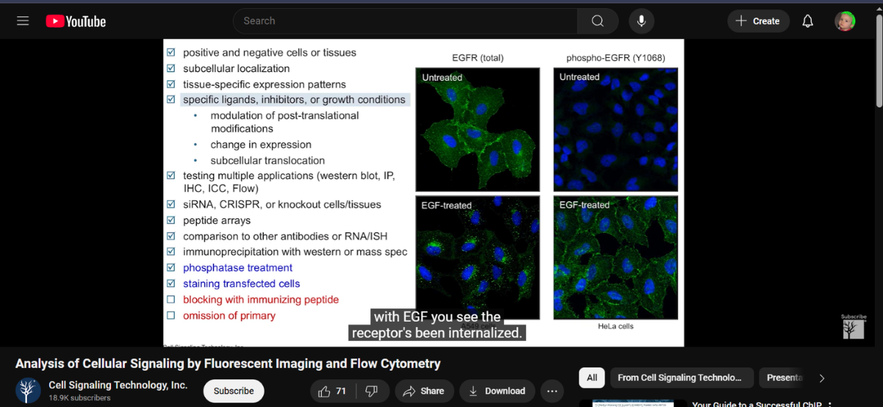

Potential Problems
List 3 potential problems you saw during your observation. These may or may not be fully related to your problem space. Describe what happened, and how you believe the problem occurred. Describe any other relevant details, including but not limited to how the people in the area reacted, if there were already solutions in place that were ignored, etc. Include a picture of the problems as you are able.

6:14 – inconsistent imaging across multiple applications
- Clone cells appear very similar on one application, but when using other applications, they all look very different.
- It could occur due to inconsistency in the applications or due to inconsistency in antibodies that look very similar.

11:21 – poorly validated reagents resulting in poor reproducibility.
- Only 28% of research studies could be replicated, another study found that only 11% could be reproduced
- Due to bias, lack of proper control, and antibodies/reagents

Cost – all the methods mentioned in the video seem very costly and were done by companies. This then gives us the need for our group to develop cheaper cell imaging analysis so that these staining techniques can be minimized.

14:55 – Nuclear Stain vs. Nucleolar stain
- Different staining techniques provide different visual results. Thus, if we gather stained cell image data, we need to be careful as to what types of stains are used. For this project, we are focusing on counting cells, thus cell membrane staining may be the most effective data to choose from.
- Nuclear stain highlights the a cell’s nucleus and may highlight the nucleolus.
- Nucleolar staining highlights the cell’s nucleolus clearly.
- Cell membrane staining highlights the cells entire cell membrane boundary, and may or may not highlight subcellular systems.

Experiences
Did you experience any of the problems first hand? What was that experience like? Were you able to talk to any of the people who experienced these problems? What did they say? Did people at this location mention other problems not immediately visible? Were you able to go observe those problems or ask follow up questions about them?

As of now, we have no first-hand experience with any problem. Most, if not all, of our work will be within Matlab so the problems will most likely be avoided. The video was approved by Dr. Wynne to give us a foundational understanding of Flow Cytometry and Fluorescent Imaging to see how our MATLAB program may behave.

Other
Any other additional information you may want to remember.
- Flow Cytometry is immunofluorescent analysis on cells in suspension.
- Differing protocols for staining cells and tissues heavily impact imaging results
- Which data protocols should we try to gather data from to best be able to distinguish the background and cells.
One used protocol for Flow Cytometry is Fixation
- 4% formaldehyde final concentration, 10 minutes at 37C..

